Machine Learning, Big Data and Visualization

Hands-on lab step-by-step

July 2018

Information in this document, including URL and other Internet Web site references, is subject to change without notice. Unless otherwise noted, the example companies, organizations, products, domain names, e-mail addresses, logos, people, places, and events depicted herein are fictitious, and no association with any real company, organization, product, domain name, e-mail address, logo, person, place or event is intended or should be inferred. Complying with all applicable copyright laws is the responsibility of the user. Without limiting the rights under copyright, no part of this document may be reproduced, stored in or introduced into a retrieval system, or transmitted in any form or by any means (electronic, mechanical, photocopying, recording, or otherwise), or for any purpose, without the express written permission of Microsoft Corporation.

Microsoft may have patents, patent applications, trademarks, copyrights, or other intellectual property rights covering subject matter in this document. Except as expressly provided in any written license agreement from Microsoft, the furnishing of this document does not give you any license to these patents, trademarks, copyrights, or other intellectual property.

The names of manufacturers, products, or URLs are provided for informational purposes only and Microsoft makes no representations and warranties, either expressed, implied, or statutory, regarding these manufacturers or the use of the products with any Microsoft technologies. The inclusion of a manufacturer or product does not imply endorsement of Microsoft of the manufacturer or product. Links may be provided to third party sites. Such sites are not under the control of Microsoft and Microsoft is not responsible for the contents of any linked site or any link contained in a linked site, or any changes or updates to such sites. Microsoft is not responsible for webcasting or any other form of transmission received from any linked site. Microsoft is providing these links to you only as a convenience, and the inclusion of any link does not imply endorsement of Microsoft of the site or the products contained therein.

© 2018 Microsoft Corporation. All rights reserved.

Microsoft and the trademarks listed at <https://www.microsoft.com/en-us/legal/intellectualproperty/Trademarks/Usage/General.aspx> are trademarks of the Microsoft group of companies. All other trademarks are property of their respective owners.

Contents

Machine Learning, Big Data and Visualization hands-on lab step-by-step 1

Abstract and learning objectives 1

Overview 1

Solution architecture 2

Requirements 2

Before the hands-on lab 3

Task 1: Deploy Databricks cluster, Azure ML, and Storage Accounts to Azure 3

Task 2: Register for a trial API account at WeatherUnderground.com 6

Task 3: Deploy Lab Virtual Machine (Lab VM) to Azure 9

Task 4: Install Power BI Desktop on the Lab VM 10

Exercise 1: Build a Machine Learning Model 15

Task 1: Navigate to Machine Learning Studio 15

Task 2: Upload the Sample Datasets 15

Task 3: Start a new experiment 18

Task 4: Prepare flight delay data 18

Task 5: Prepare the weather data 24

Task 6: Join the Flight and Weather datasets 29

Task 7: Train the model 35

Task 8: Operationalize the experiment 39

Task 9: Deploy Web Service and Note API Information 45

Exercise 2: Deploy intelligent web app 48

Task 1: Deploy web app from GitHub 48

Exercise 3: Setup Azure Data Factory 51

Task 1: Connect to the Lab VM 51

Task 2: Download and stage data to be processed 52

Task 3: Create an Azure Data Factory 56

Exercise 4: Operationalize ML scoring with Azure ML and Data Factory 57

Task 1: Create Azure Blob Storage Linked Service 57

Task 2: Create Azure AML Linked Service 61

Task 3: Create a Pipeline 63

Task 4: Run & Monitor pipeline activities 67

Exercise 5: Summarize data using Databricks 68

Task 1: Login to the Databricks portal and ensure your cluster is running 68

Task 2: Summarize delays by airport 70

Exercise 6: Visualizing in Power BI Desktop 75

Task 1: Connect to the Lab VM 75

Task 2: Connect to Databricks Power BI Desktop 76

Task 3: Create Power BI report 82

After the hands-on lab 88

Task 1: Delete resource group 88

Appendix A: Alternative to Azure ML Exercise 89

Task 1: Import the Completed Predictive Experiment Into Your Workspace 89

Appendix B: Alternative to Azure Data Factory Exercise 92

Task 1: Download the Pre-Scored File 92

# Machine Learning, Big Data and Visualization hands-on lab step-by-step

## Abstract and learning objectives

In this workshop, you will deploy a web app using Machine Learning (ML) to predict travel delays given flight delay data and weather conditions. Plan a bulk data import operation, followed by preparation, such as cleaning and manipulating the data for testing, and training your Machine Learning model.

By attending this workshop, you will be better able to build a complete Azure Machine Learning (ML) model for predicting if an upcoming flight will experience delays. In addition, you will learn to:

* Integrate the Azure ML web service in a Web App for both one at a time and batch predictions
* Use Azure Data Factory (ADF) for data movement and operationalizing ML scoring
* Summarize data with Azure Databricks and Spark SQL
* Visualize batch predictions on a map using Power BI

This hands-on lab is designed to provide exposure to many of Microsoft’s transformative line of business applications built using Microsoft big data and advanced analytics. The goal is to show an end-to-end solution, leveraging many of these technologies, but not necessarily doing work in every component possible. The lab architecture is below and includes:

* Azure Machine Learning (Azure ML)
* Azure Data Factory (ADF)
* Azure Storage
* Azure Databricks
* Power BI Desktop
* Azure App Service

## Overview

AdventureWorks Travel (AWT) provides concierge services for business travelers. In an increasingly crowded market, they are always looking for ways to differentiate themselves, and provide added value to their corporate customers.

They are looking to pilot a web app that their internal customer service agents can use to provide additional information useful to the traveler during the flight booking process. They want to enable their agents to enter in the flight information and produce a prediction as to whether the departing flight will encounter a 15-minute or longer delay, considering the weather forecasted for the departure hour.

In this hands-on lab, attendees will build an end-to-end solution to predict flight delays, accounting for the weather forecast.

## Solution architecture

Below is a diagram of the solution architecture you will build in this lab. Please study this carefully so you understand the whole of the solution as you are working on the various components.

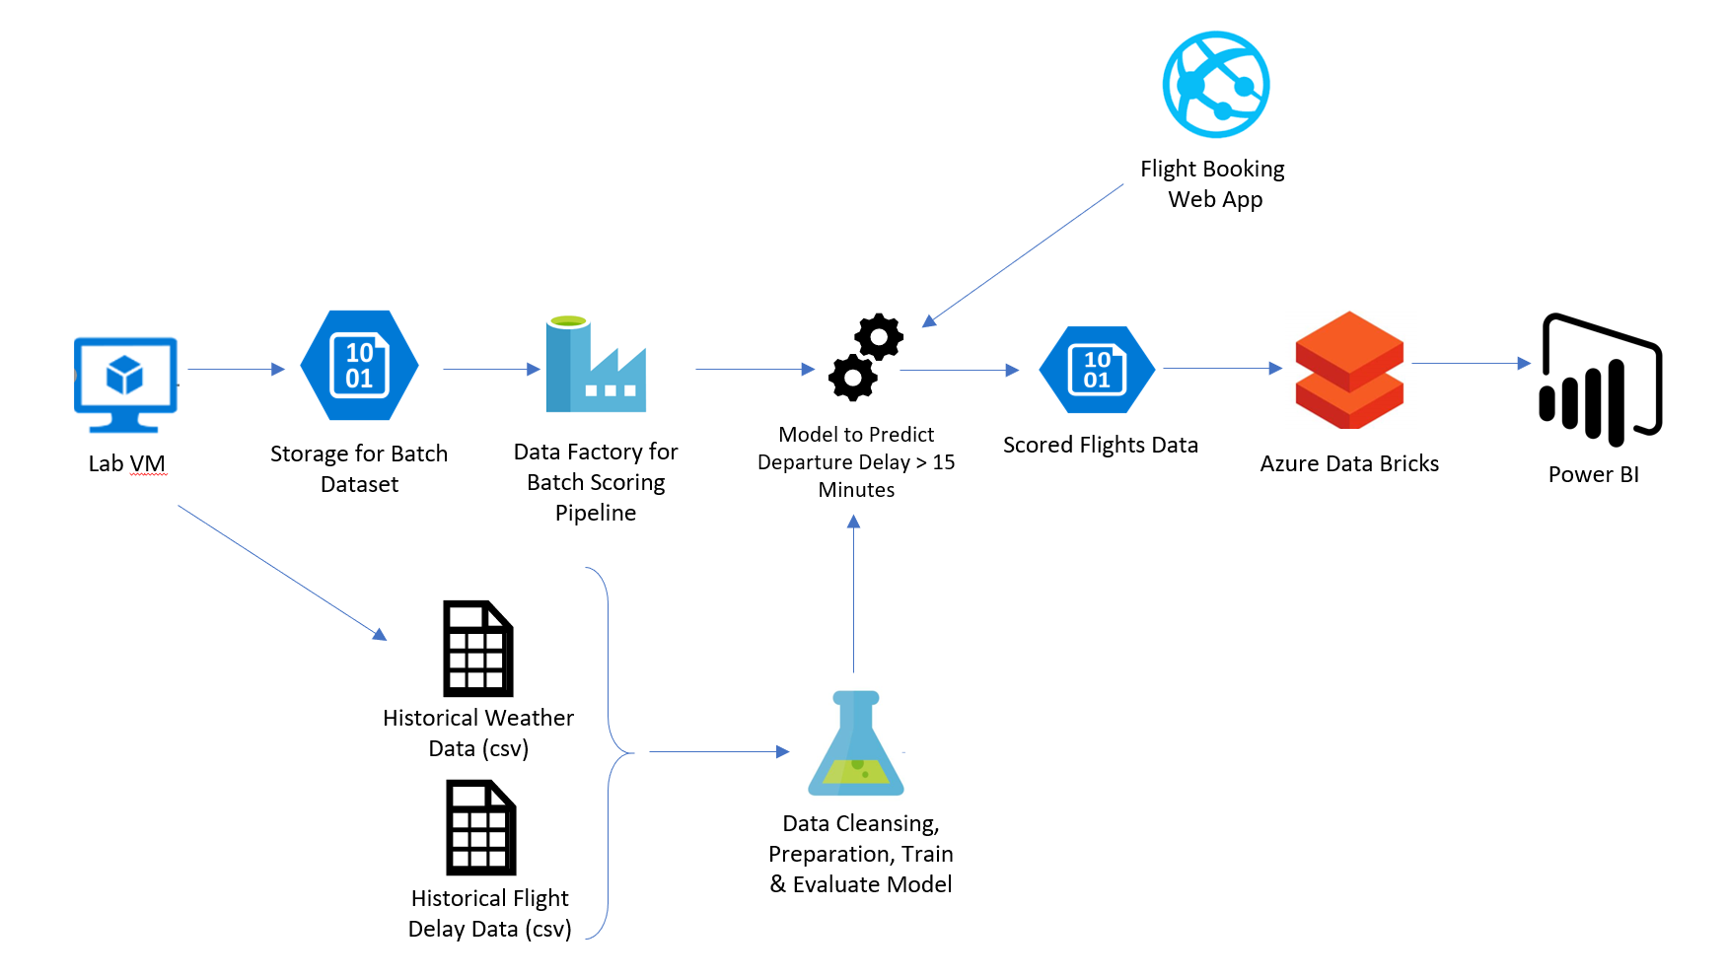

The solution begins with using Azure Machine Learning (Azure ML) to develop a two-class classification machine learning model based on historical data, which would then be operationalized as a Predictive Web Service using ML Studio that can be accessed for real-time flight delay predictions in a Web application. After operationalizing the ML model, an ADF pipeline, using a Linked Service pointing to Azure ML’s Batch Execution API and an AzureMLBatchExecution activity, will be used to apply the operational model to data in batch as it is moved to the proper location in Azure storage. The scored data in Azure storage can then be explored and prepared using Azure Databricks, and the results visualized using a map visualization in Power BI.

## Requirements

1. Microsoft Azure subscription must be pay-as-you-go or MSDN
   1. Trial subscriptions will not work

## Before the hands-on lab

Duration: 45 minutes

In this exercise, you will set up your environment for use in the rest of the hands-on lab. You should follow all the steps provided in the Before the Hands-on Lab section to prepare your environment *before* attending the hands-on lab.

#### Task 1: Deploy Databricks cluster, Azure ML, and Storage Accounts to Azure

1. CTRL+Click the **Deploy to Azure** button below, and you will be taken to the Azure portal, and presented with a form for a new custom deployment (which uses an Azure Resource Management (ARM) template from a GitHub repository). You will be presented with a blade to provide some custom parameters as show in the screenshot below.

[](https://portal.azure.com/#create/Microsoft.Template/uri/https%3A%2F%2Fraw.githubusercontent.com%2Fchmitch%2Focp-big-data-and-visualization%2Fmaster%2FTemplates%2FTemplate-Prerequsites.json)

1. In the Custom deployment blade that appears, enter the following values:
   1. Subscription: Select your subscription
   2. Resource group: Use and existing Resource group or create a new one by entering a unique name, such as **“bigdatalab-[your intials or first name]”.**
   3. Location: Select a location for the Resource group. Recommend using East US, East US 2, or West US 2, as some resources, such as Data Factory, are only available in those regions.
   4. Workspace name: Enter a unique name, such as your initials or first name. This value must be between 3 and 10 characters long, and should not contain any special characters. Note the name, as you will need to use it in your Lab VM deployment in Task 3 as well.
   5. Check the box to agree to the terms.
   6. Select **Purchase**.   
      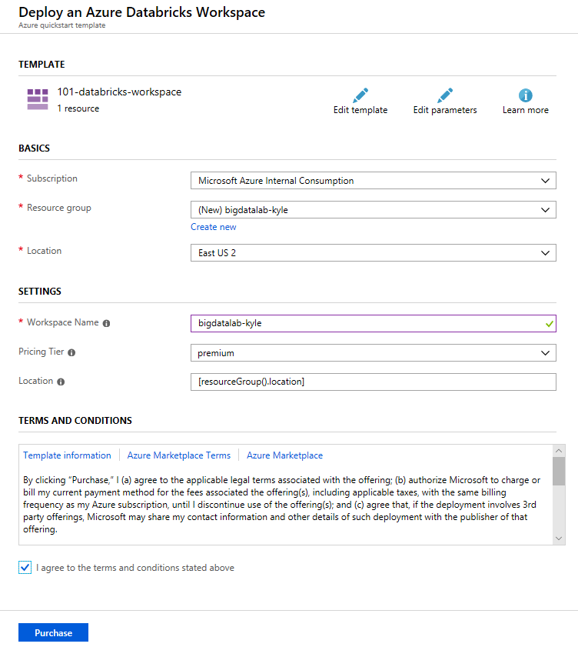
2. The deployment will take about 2-5 minutes to complete.
3. Wait for the cluster creation to complete, then navigate to the resource in the Azure portal and click. “Launch Workspace”.  
   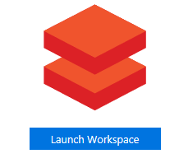
4. Once in the Databricks environment click “New Cluster” to provision your compute nodes.  
   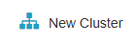
5. Give your cluster a unique name such as **“bigdatalab-[your intials or first name]”** for convenience, and click “Create Cluster”.  
   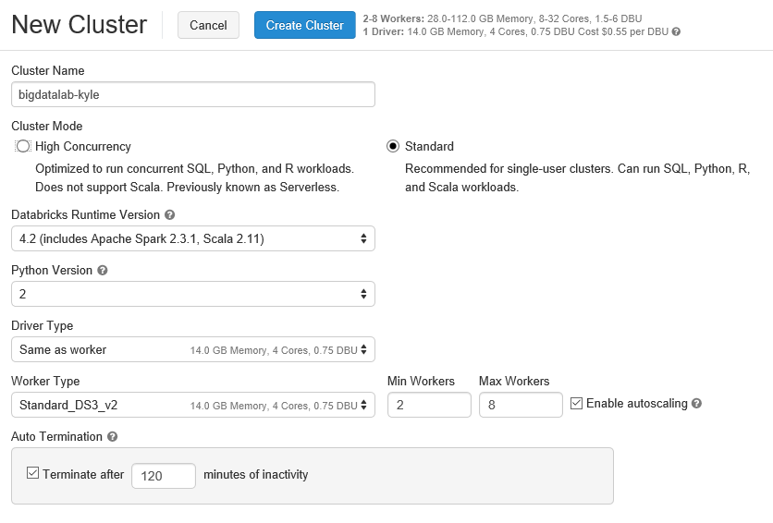
6. The cluster creation will take 5 – 10 minutes to complete.
7. Wait for the deployment to complete before attempting to deploy the Lab Virtual Machine in Task 3, as it depends on the Virtual Network created by this deployment. In the meantime, you can move on to the next task, Task 2, while this deployment is ongoing.

#### Task 2: Register for a trial API account at WeatherUnderground.com

To retrieve the 10-day hourly weather forecast, you will use an API from WeatherUnderground.com. There is a free developer version that provides you access to the API you need for this hands-on lab.

1. Navigate to <https://www.wunderground.com/signup>
2. Complete the Create an Account form by providing your email address and a password, and agreeing to the terms. Select Sign up for free.

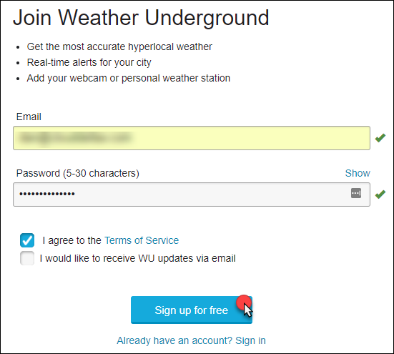

1. Navigate to <https://www.wunderground.com/login>.
2. Once logged into Weather Underground navigate to <http://www.wunderground.com/weather/api/>.
3. Select **Explore My Options**.

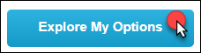

1. On the Get Your API Key page, select **Anvil Plan**. 
2. Scroll down until you see the area titled How much will you use our service? Ensure **Developer** is selected. 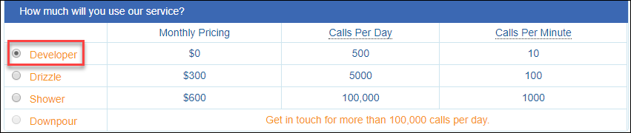
3. Select **Purchase Key**.

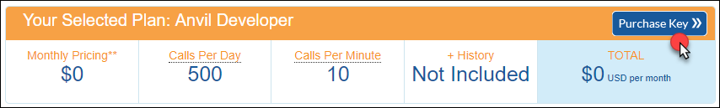

1. Complete the brief contact form. For Project Name and Project Web use the input **MCW** (Microsoft Cloud Workshop). When answering where will the API be used, select **Website**. For Will the API be used for commercial use and Will the API be used for manufacturing mobile chip processing, select **No**. Select **Purchase Key**.

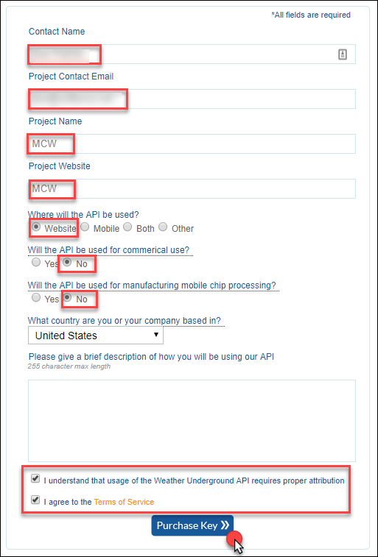

1. You should be taken to a page that displays your key, like the following. Take note of your API Key. It is available from the text box labeled **Key ID**.

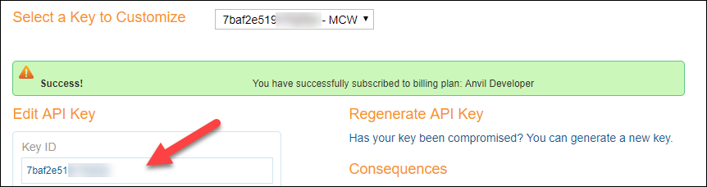

1. To verify that your API Key is working, modify the following URL to include your API Key: [http://api.wunderground.com/api/<YOURAPIKEY>/hourly10day/q/SEATAC.json](http://api.wunderground.com/api/%3cYOURAPIKEY%3e/hourly10day/q/SEATAC.json)
2. Open your modified link in a browser, you should get a JSON result showing the 10-day, hourly weather forecast for the Seattle-Tacoma International Airport.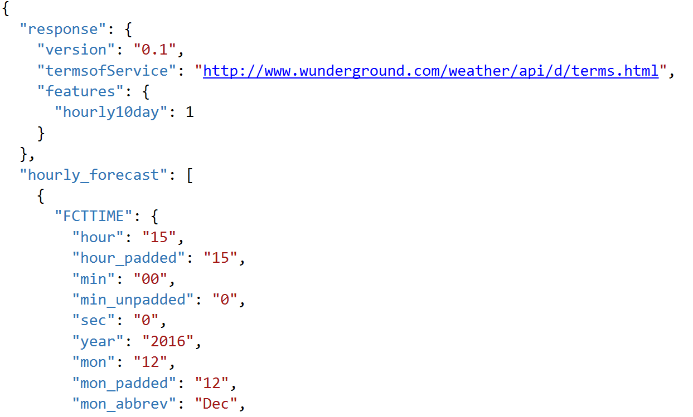

#### Task 3: Deploy Lab Virtual Machine (Lab VM) to Azure

1. CTRL+Click the **Deploy to Azure** button below, and you will be taken to the Azure portal, and presented with a form for a new custom deployment (which uses an ARM template from a GitHub repository). You will be presented with a blade to provide some custom parameters as show in the screenshot below. [](https://portal.azure.com/#create/Microsoft.Template/uri/https%3A%2F%2Fraw.githubusercontent.com%2Fchmitch%2Focp-big-data-and-visualization%2Fmaster%2FTemplates%2FTemplate-VM.json)
2. In the Custom deployment blade that appears, enter the following values:
   1. Subscription: Select your subscription
   2. Resource group: Choose Use Existing, and select the same resource group you used when deploying your HDInsight cluster and Azure ML workspace, above.
   3. Location: The location should be automatically selected to be the same as your Resource Group.
   4. App name: IMPORTANT: You must enter the same App name you used in the deployment above in Task
   5. VM User Name: Enter a name, or accept the default. Note all references to this in the lab use the default user name, demouser, so if you change it, please note it for future reference throughout the lab.
   6. VM Password: Enter a password, or accept the default. Note all references to this in the lab use the default password, Password.1!!, so if you change it, please not it for future reference throughout the lab.
   7. Check the box to agree to the terms.
   8. Select **Purchase**. 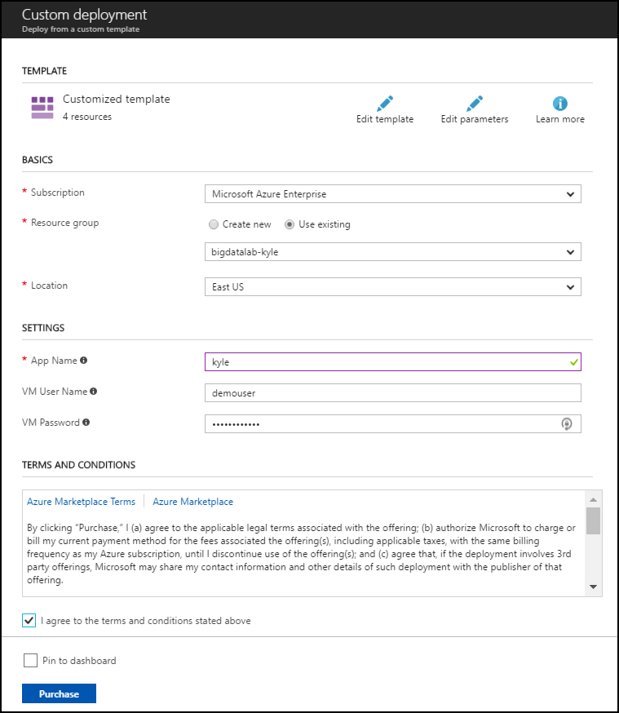
3. The deployment will take about 10 minutes to complete.

#### Task 4: Install Power BI Desktop on the Lab VM

1. Connect to the Lab VM. (If you are already, connected to your Lab VM, skip to Step 7.)
2. From the left side menu in the Azure portal, click on **Resource groups**, then enter your resource group name into the filter box, and select it from the list. 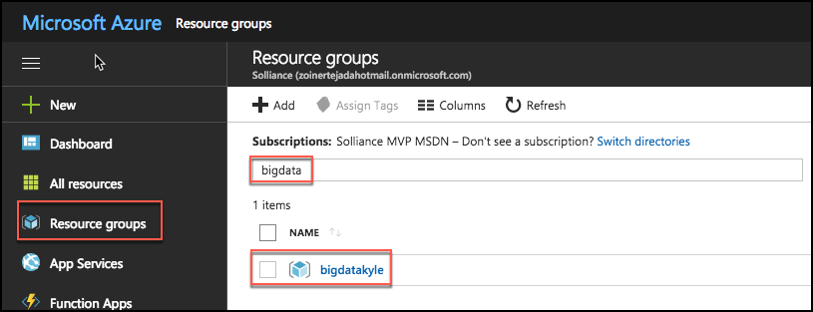
3. Next, select your lab virtual machine from the list. 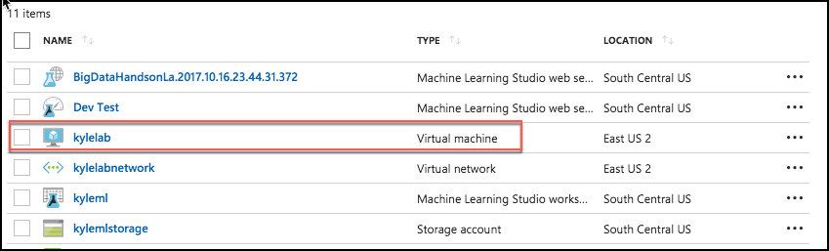
4. On your Lab VM blade, select **Connect** from the top menu. 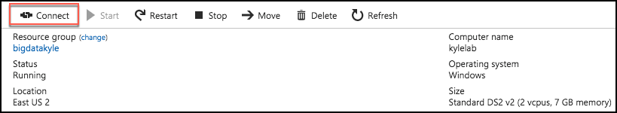
5. Download and open the RDP file.
6. Select Connect, and enter the following credentials (or the non-default credentials if you changed them):
   * User name: demouser
   * Password: Password.1!!
7. In a web browser on the Lab VM navigate to the Power BI Desktop download page <https://powerbi.microsoft.com/en-us/desktop/>
8. Select the Download Free link in the middle of the page.
9. Run the installer.
10. Select Next on the welcome screen. 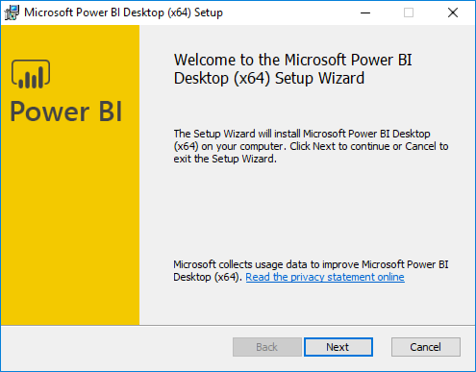
11. Accept the license agreement, and select Next. 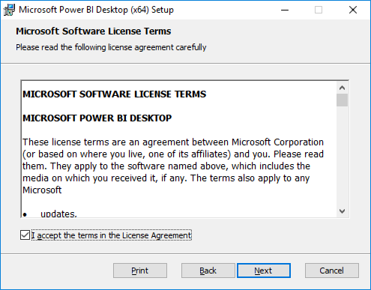
12. Leave the default destination folder, and select Next. 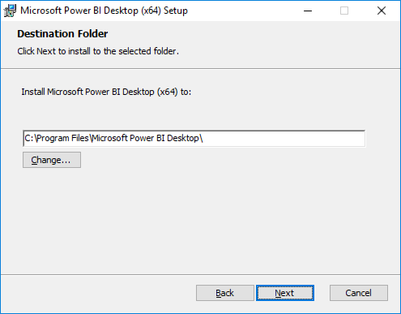
13. Make sure the Create a desktop shortcut box is checked, and select Install. 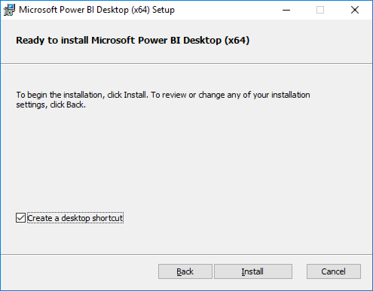
14. Uncheck Launch Microsoft Power BI Desktop, and select Finish. 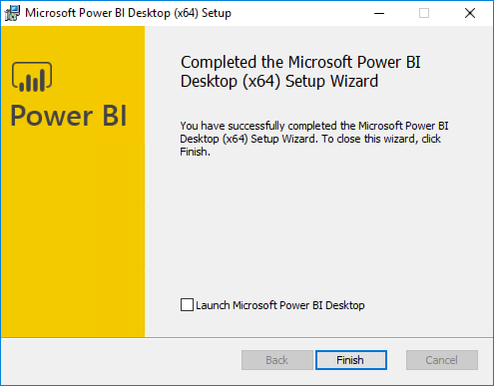

## Exercise 1: Build a Machine Learning Model

Duration: 90 minutes

In this exercise, attendees will implement a classification experiment. They will load the training data from their local machine into a dataset. Then, they will explore the data to identify the primary components they should use for prediction, and use two different algorithms for predicting the classification. They will evaluate the performance of both and algorithms choose the algorithm that performs best. The model selected will be exposed as a web service that is integrated with the sample web app.

#### Task 1: Navigate to Machine Learning Studio

1. From your Lab VM open a browser and navigate to the Azure portal (<https://portal.azure.com>), and navigate to your Machine Learning Studio workspace under the Resource Group you created when completing the prerequisites for this hands-on lab. 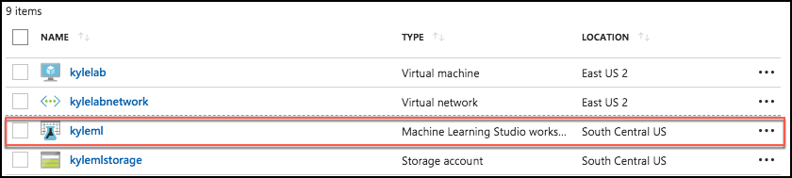
2. On the Machine Learning Studio workspace blade, select **Launch Machine Learning Studio**. 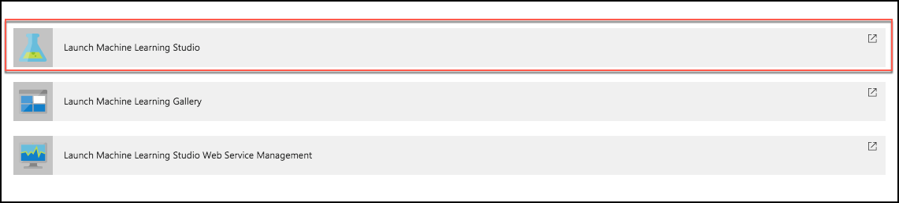
3. Sign in.

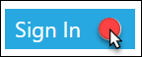

1. If you have multiple Azure ML workspaces, choose the one you created for this hands-on lab from the drop-down menu near the top right of Azure Machine Learning Studio. 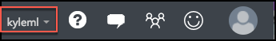

#### Task 2: Upload the Sample Datasets

1. Before you begin creating a machine learning experiment, there are three datasets you need to load.
2. Download the three CSV sample datasets from here: <http://bit.ly/2wGAqrl> (If you get an error, or the page won’t open, try pasting the URL into a new browser window and verify the case sensitive URL is exactly as shown).
3. Extract the ZIP and verify you have the following files:

* FlightDelaysWithAirportCodes.csv
* FlightWeatherWithAirportCodes.csv
* AirportCodeLocationLookupClean.csv

1. In the Machine Learning Studio browser window, select **+ NEW** at the bottom left. 
2. Select **Dataset** under New, and then select **From Local File**.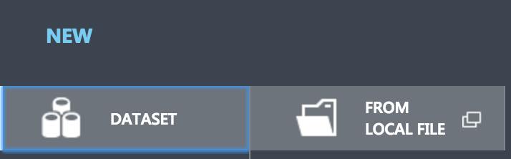
3. In the dialog that appears, select **Choose File**, browse to the FlightDelaysWithAirportCodes.csv file you downloaded in the previous step, and select **Open**.

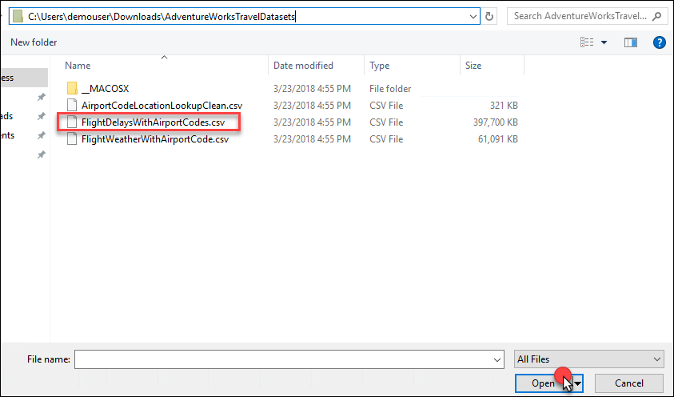

1. Change the name of the dataset to "FlightDelaysWithAirportCodes," and select the checkmark to upload the data into a new dataset.

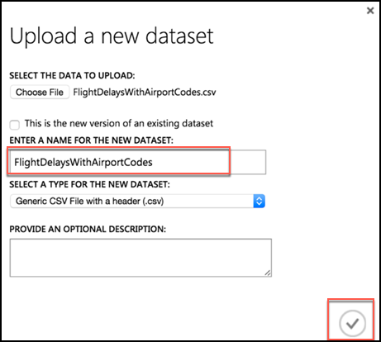

1. Repeat the previous step for the FlightWeatherWithAirportCode.csv and AirportCodeLocationsClean.csv files, setting the name for each dataset in a similar fashion. There should be a total of three files that are uploaded.

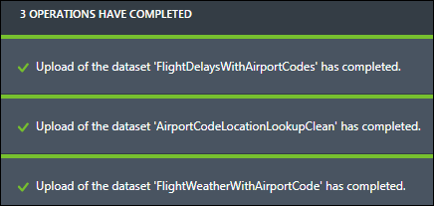

#### Task 3: Start a new experiment

1. Select **+ NEW** in the command bar at the bottom left of the page, and select **Experiment**.
2. From the options that appear, select **Blank Experiment**. 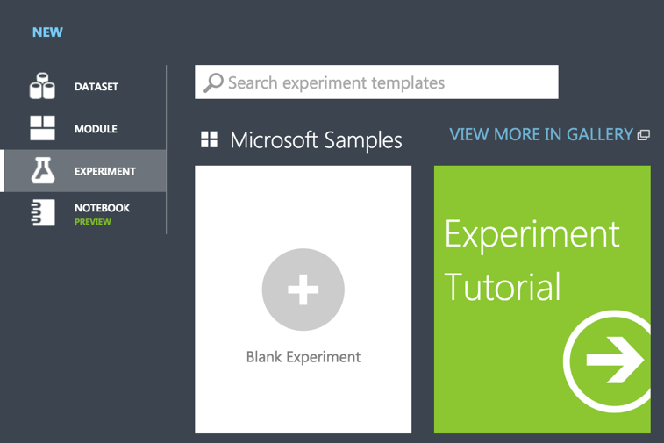
3. Give your new experiment a name, such as AdventureWorks Travel by editing the "Experiment created on ..." label near the top of the design surface. 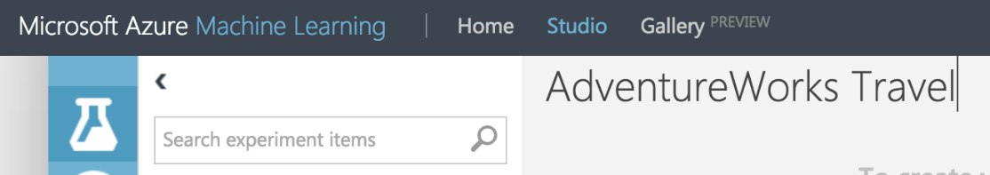

#### Task 4: Prepare flight delay data

1. In the toolbar on the left, in the **Search experiment items** box, type the name of the dataset you created with flight delay data (FlightDelaysWithAirportCodes). You should see a component for it listed under Saved Datasets, My Datasets.

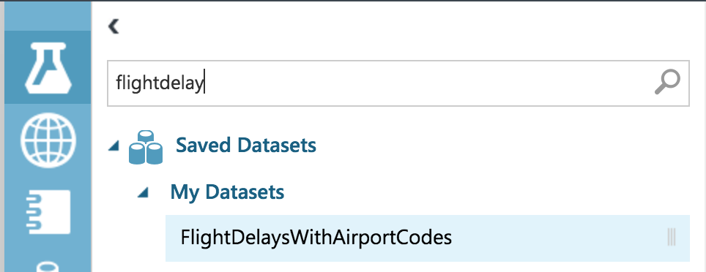

1. Select and drag the **FlightDelaysWithAirportCodes** module onto the design surface.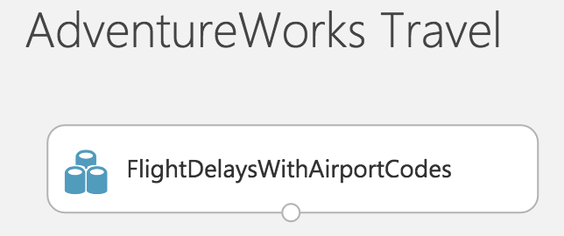
2. Next, you will explore the Flight delays datasets to understand what kind of cleanup (e.g., data munging) will be necessary.
3. Hover over the output port of the **FlightDelaysWithAirportCodes** module. 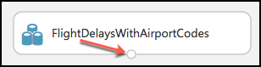
4. Right-click on the port and select **Visualize**.

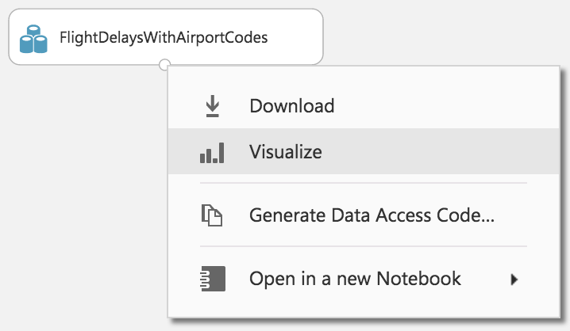

1. A new dialog will appear showing a maximum of 100 rows by 100 columns sample of the dataset. You can see at the top that the dataset has a total of 2,719,418 rows (also referred to as examples in Machine Learning literature) and has 20 columns (also referred to as features). 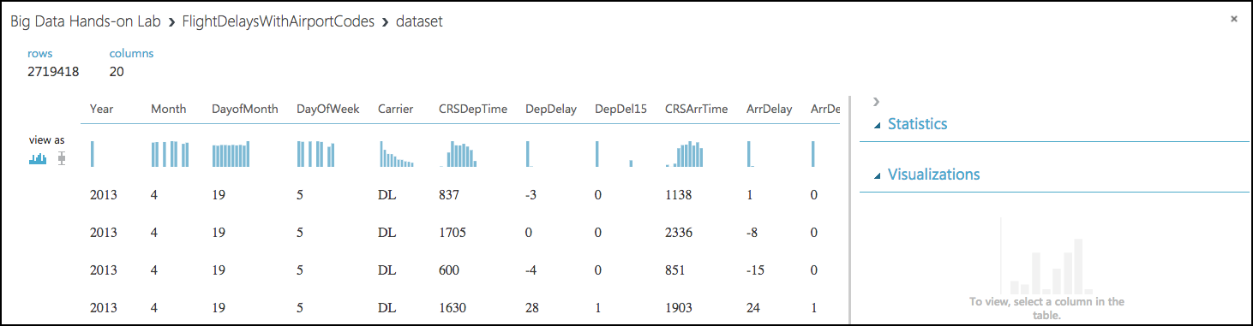
2. Because all 20 columns are displayed, you can scroll the grid horizontally. Scroll until you see the **DepDel15** column, and select it to view statistics about the column. The DepDel15 column displays a 1 when the flight was delayed at least 15 minutes and 0 if there was no such delay. In the model you will construct, you will try to predict the value of this column for future data. Notice in the Statistics panel that a value of 27444 appears for Missing Values. This means that 27,444 rows do not have a value in this column. Since this value is very important to our model, we will need to eliminate any rows that do not have a value for this column.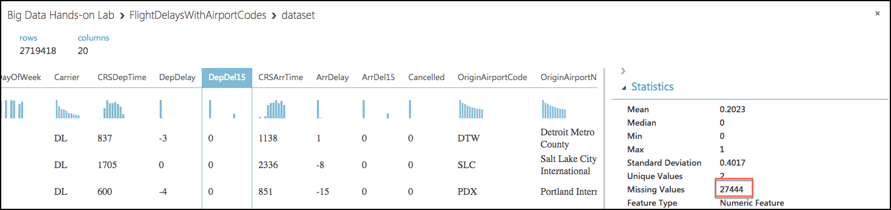
3. Next, select the **CRSDepTime** column. Our model will approximate departure times to the nearest hour, but departure time is captured as an integer. For example, 8:37 am is captured as 837. Therefore, we will need to process the CRSDepTime column, and round it down to the nearest hour. To perform this rounding will require two steps, first you will need to divide the value by 100 (so that 837 becomes 8.37). Second, you will round this value down to the nearest hour (so that 8.37 becomes 8).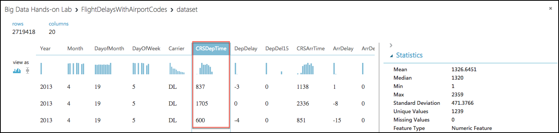
4. Finally, we do not need all 20 columns present in the FlightDelaysWithAirportCodes dataset, so we will need to pare down the columns in the dataset to the 12.
5. Close the Visualize dialog, and go back to the design surface.
6. To perform our data munging, we have multiple options, but in this case, we’ve chosen to use an **Execute R Script** module, which will perform the following tasks:
   1. Remove rows with missing values
   2. Generate a new column, named “CRSDepHour,” which contains the rounded down value from CRSDepTime
   3. Pare down columns to only those needed for our model
7. To add the module, search for **Execute R Script** by entering “Execute R” into the Search experiment items box.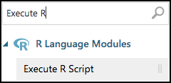
8. Drag this module on to the design surface beneath your FlightDelaysWithAirportCodes dataset. Select the small circle at the bottom of the FlightDelaysWithAirportCodes dataset, drag and release when your mouse is over the circle found in the top left of the Execute R Script module. These circles are referred to as ports, and by taking this action you have connected the output port of the dataset with the input port of the Execute R Script module, meaning data from the dataset will flow along this path.

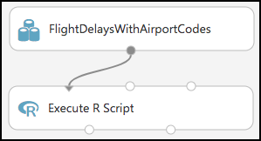

1. In the **Properties** panel for **Execute R Script** module, select the **Double Windows** icon to maximize the script editor. 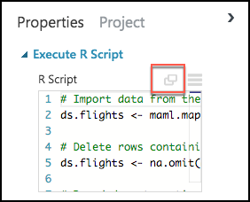
2. Replace the script with the following (Press CTRL+A to select all then CTRL+V to paste)

# Import data from the input port

ds.flights <- maml.mapInputPort(1)

# Delete rows containing missing values

ds.flights <- na.omit(ds.flights)

# Round departure times down to the nearest hour, and export the result as a new column named "CRSDepHour"

ds.flights[, "CRSDepHour"] <- floor(ds.flights[, "CRSDepTime"] / 100)

# Trim the columns to only those we will use for the predictive model

ds.flights = ds.flights[, c("OriginAirportCode","OriginLatitude", "OriginLongitude", "Month", "DayofMonth", "CRSDepHour", "DayOfWeek", "Carrier", "DestAirportCode", "DestLatitude", "DestLongitude", "DepDel15")]

# Export the cleaned up data set

maml.mapOutputPort("ds.flights");

1. Select the check mark in the bottom right to save the script (Do not worry if the formatting is off before selecting the check mark.)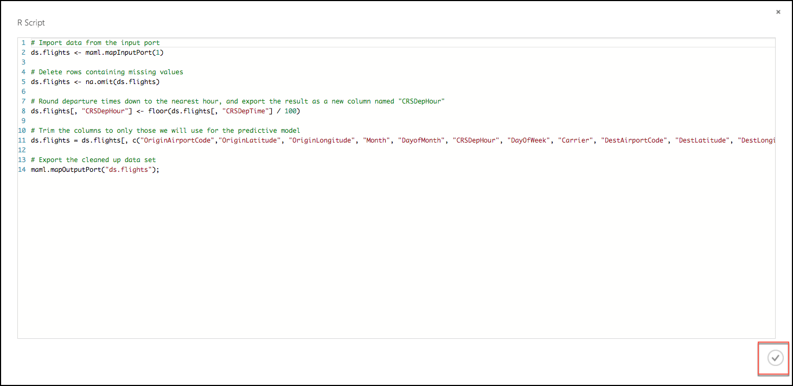
2. Select **Save** on the command bar at the bottom to save your in-progress experiment. 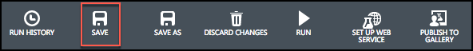
3. Select **Run** in the command bar at the bottom to run the experiment. 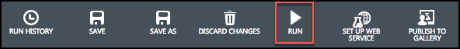
4. When the experiment is finished running, you will see a finished message in the top right corner of the design surface, and green check marks over all modules that ran.

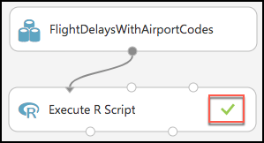

1. You should run your experiment whenever you need to update the metadata describing what data is flowing through the modules, so that newly added modules can be aware of the shape of your data (most modules have dialogs that can suggest columns, but before they can make suggestions you need to have run your experiment).
2. To verify the results of our R script, right-click the left output port (Result Dataset) of the Execute R Script module and select **Visualize**.

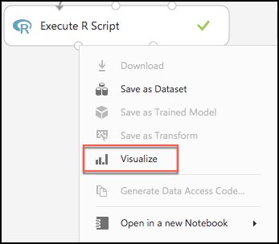

1. In the dialog that appears, scroll over to DepDel15 and select the column. In the statistics you should see that Missing Values reads 0. 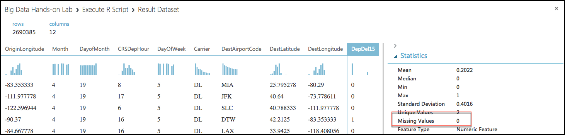
2. Now, select the CRSDepHour column, and verify that our new column contains the rounded hour values from our CRSDepTime column. 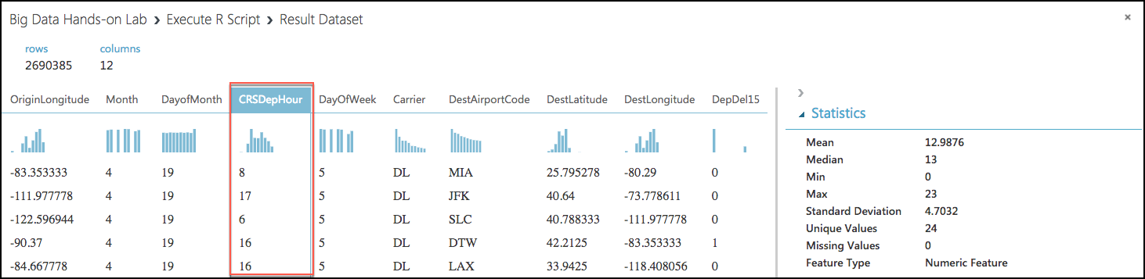
3. Finally, observe that we have reduced the number of columns from 20 to 12. Close the dialog. 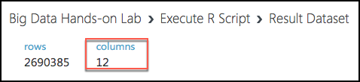
4. At this point the Flight Delay Data is prepared, and we turn to preparing the historical weather data.

#### Task 5: Prepare the weather data

1. To the right of the **FlightDelaysWithAirportCodes** dataset, add the **FlightWeatherWithAirportCodes** dataset. 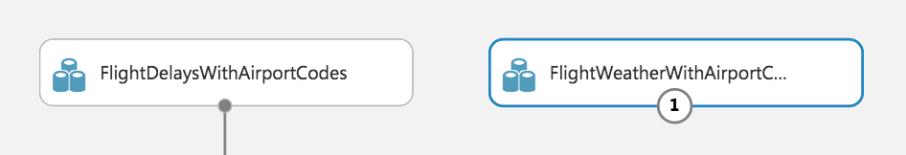
2. Right-click the output port of the **FlightWeatherWithAirportCodes** dataset and select **Visualize**. 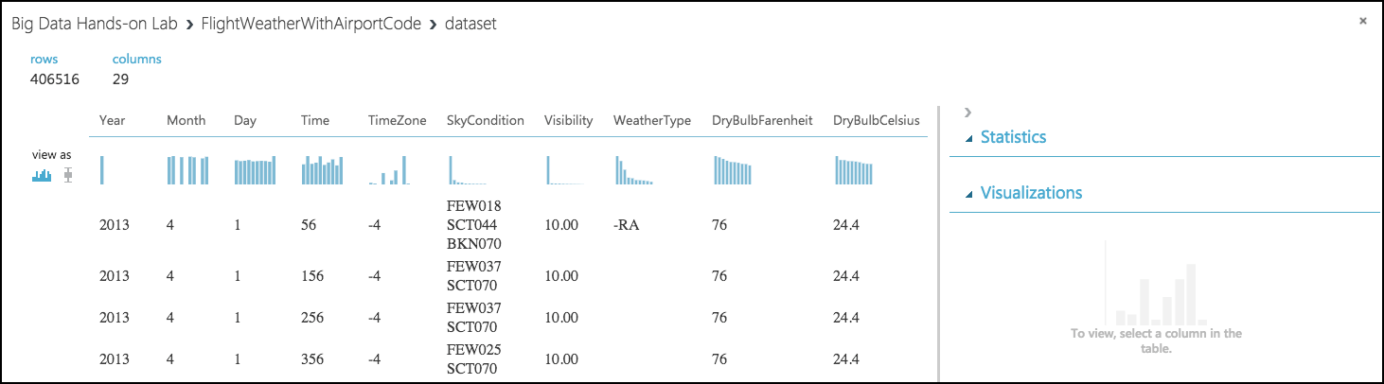
3. Observe that this data set has 406,516 rows and 29 columns. For this model, we are going to focus on predicting delays using WindSpeed (in MPH), SeaLevelPressure (in inches of Hg), and HourlyPrecip (in inches). We will focus on preparing the data for those features.
4. In the dialog, select the **WindSpeed** column, and review the statistics. Observe that the Feature Type was inferred as String and that there are 32 Missing Values. Below that, examine the histogram to see that, even though the type was inferred as string, the values are all actually numbers (e.g. the x-axis values are 0, 6, 5, 7, 3, 8, 9, 10, 11, 13). We will need to ensure that we remove any missing values and convert WindSpeed to its proper type as a numeric feature. 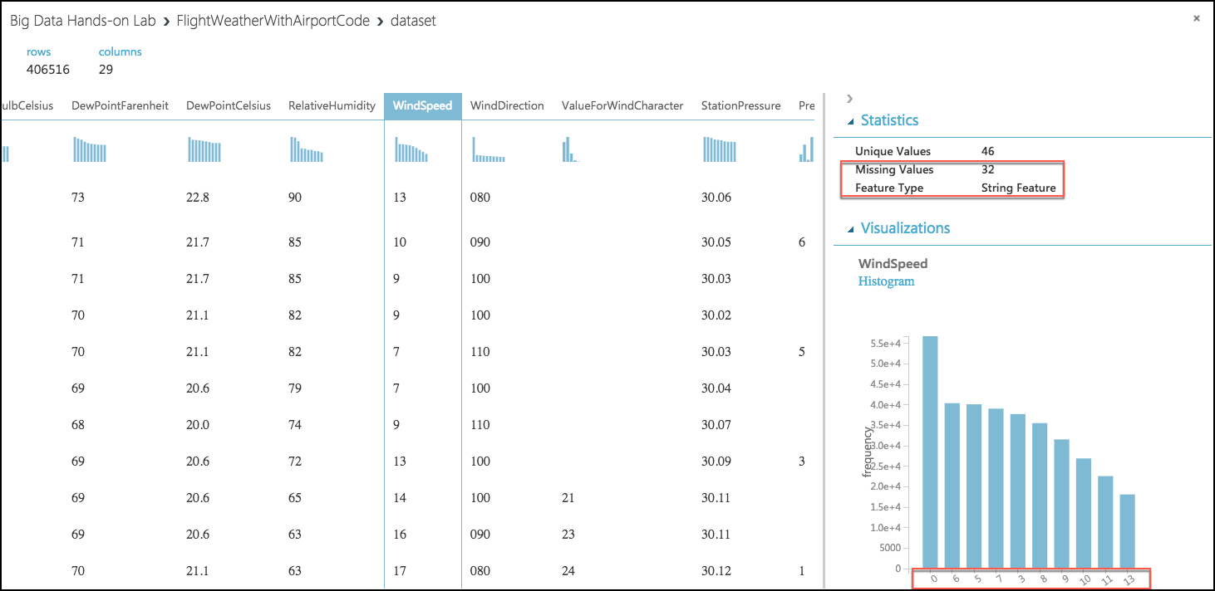
5. Next, select the **SeaLevelPressure** column. Observe that the Feature Type was inferred as String and there are 0 Missing Values. Scroll down to the histogram, and observe that many of the features are of a numeric value (e.g., 29.96, 30.01, etc.), but there are many features with the string value of M for Missing. We will need to replace this value of "M" with a suitable numeric value so that we can convert this feature to be a numeric feature. 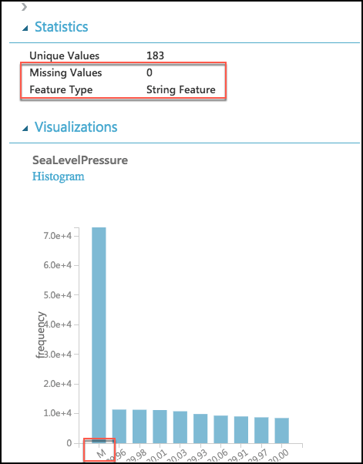
6. Finally, examine the **HourlyPrecip** feature. Observe that it too was inferred to have a Feature Type of String and is missing values for 374,503 rows. Looking at the histogram, observe that besides the numeric values, there is a value T (for Trace amount of rain). We need to replace T with a suitable numeric value and covert this to a numeric feature. 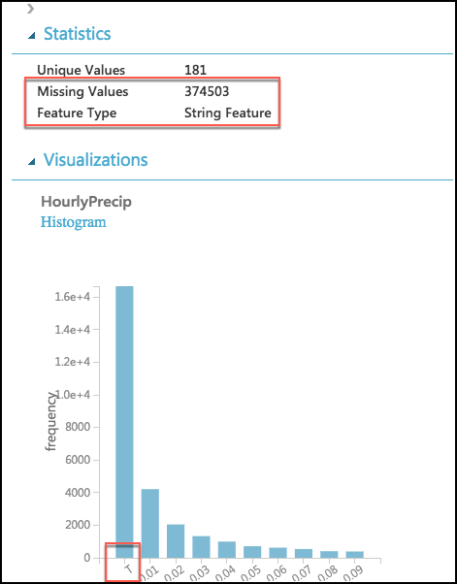
7. To preform our data cleanup, we will use a Python script, in which we will perform the following tasks:
   1. WindSpeed: Replace missing values with 0.0, and “M” values with 0.005
   2. HourlyPrecip: Replace missing values with 0.0, and “T” values with 0.005
   3. SeaLevelPressure: Replace “M” values with 29.92 (the average pressure)
   4. Convert WindSpeed, HourlyPrecip, and SeaLevelPressure to numeric columns
   5. Round “Time” column down to the nearest hour, and add value to a new column named “Hour”
   6. Eliminate unneeded columns from the dataset
8. Add an **Execute Python Script** by searching for Python.

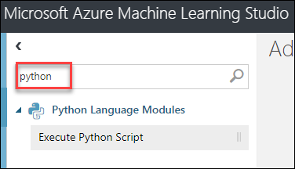

1. Add the module below the **FlightWeatherWithAirportCode** module, and connect the output port of the **FlightWeatherWithAirportCode** module to the first input port of the Execute Python Script module. 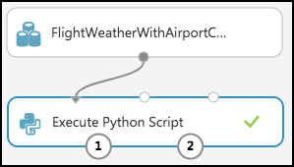
2. In the **Properties** panel for the Execute Python Script:
   1. Set the Python Version to **Anaconda 4.0/Python 3.5**
   2. Select the **Double Windows** icon to open the script editor.

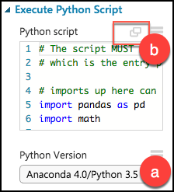

1. Paste in the following script into the Python script window, and select the checkmark at the bottom right of the dialog (press CTRL+A to select all then CTRL+V to paste and then immediately select the checkmark -- don't worry if the formatting is off before hitting the checkmark).

# imports

import pandas as pd

import math

# The entry point function can contain up to two input arguments:

# Param<dataframe1>: a pandas.DataFrame

# Param<dataframe2>: a pandas.DataFrame

def azureml_main(dataframe1 = None, dataframe2 = None):

# Round weather Time down to the next hour, since that is the hour for which we want to use flight dataframe1

# Add the rounded Time to a new column named "Hour," and append that column to the dataframe1

dataframe1["Hour"] = dataframe1["Time"].apply(roundDown)

# Replace any missing HourlyPrecip and WindSpeed values with 0.0

dataframe1["HourlyPrecip"] = dataframe1["HourlyPrecip"].fillna('0.0')

dataframe1["WindSpeed"] = dataframe1["WindSpeed"].fillna('0.0')

# Replace any WindSpeed values of "M" with 0.005

dataframe1["WindSpeed"] = dataframe1['WindSpeed'].replace(['M'], '0.005')

# Replace any SeaLevelPressure values of "M" with 29.92 (the average pressure)

dataframe1["SeaLevelPressure"] = dataframe1['SeaLevelPressure'].replace(['M'], '29.92')

# Replace any HourlyPrecip values of "T" (trace) with 0.005

dataframe1["HourlyPrecip"] = dataframe1['HourlyPrecip'].replace(['T'], '0.005')

# Convert our WindSpeed, SeaLevelPressure, and HourlyPrecip columns to numeric

dataframe1[['WindSpeed','SeaLevelPressure', 'HourlyPrecip']] = dataframe1[['WindSpeed','SeaLevelPressure', 'HourlyPrecip']].apply(pd.to_numeric)

# Pare down the variables in the Weather dataset to just the columns being used by the model

df_result = dataframe1[['AirportCode', 'Month', 'Day', 'Hour', 'WindSpeed', 'SeaLevelPressure', 'HourlyPrecip']]

# Return value must be of a sequence of pandas.DataFrame

return df_result

def roundDown(x):

z = int(math.floor(x/100.0))

return z

1. Run the experiment. Currently it should appear as follows: 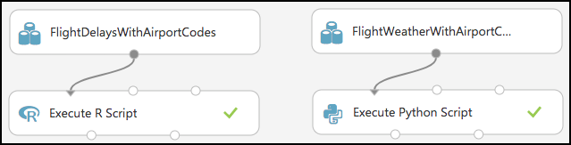

**Note:** If you receive an error in the Python script that .to_numeric does not exist, go back and verify that you selected the proper Python version.

1. Right-click the first output port of the Execute Python Script module, and select Visualize. 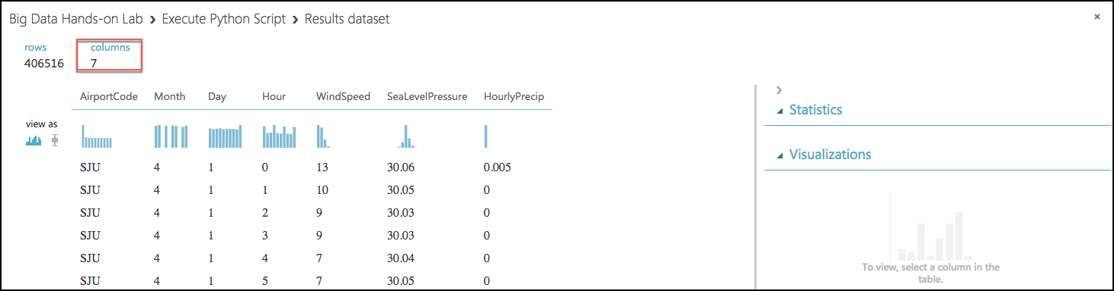
2. In the statistics, verify that there are now only the 7 columns we are interested in, and that WindSpeed, SeaLevelPressure, and HourlyPrecip are now all Numeric Feature types and that they have no missing values. 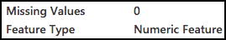

#### Task 6: Join the Flight and Weather datasets

1. With both datasets ready, we want to join them together so that we can associate historical flight delays with the weather data at departure time.
2. Drag a **Join Data** module onto the design surface, beneath and centered between both Execute R and Python Script modules. Connect the output port (1) of the Execute R Script module to input port (1) of the Join Data module, and the output port (1) of the Execute Python Script module to the input port (2) of the Join Data module. 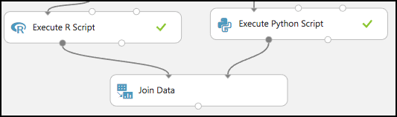
3. In the **Properties** panel for the Join Data module, relate the rows of data between the two sets L (the flight delays) and R (the weather). Select **Launch Column selector** under **Join key columns for L.**

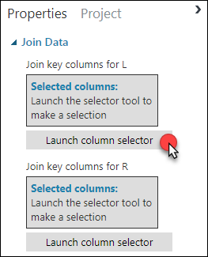

1. Set the Join key columns for L to include **OriginAirportCode, Month, DayofMonth,** and **CRSDepHour**, and select the check box in the bottom right. 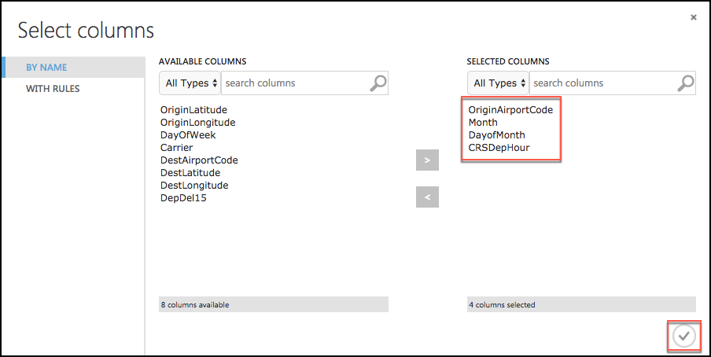
2. Select **Launch Column selector** under **Join key columns for R**. Set the join key columns for R to include **AirportCode,** **Month, Day,** and **Hour,** and select the check box in the bottom right. 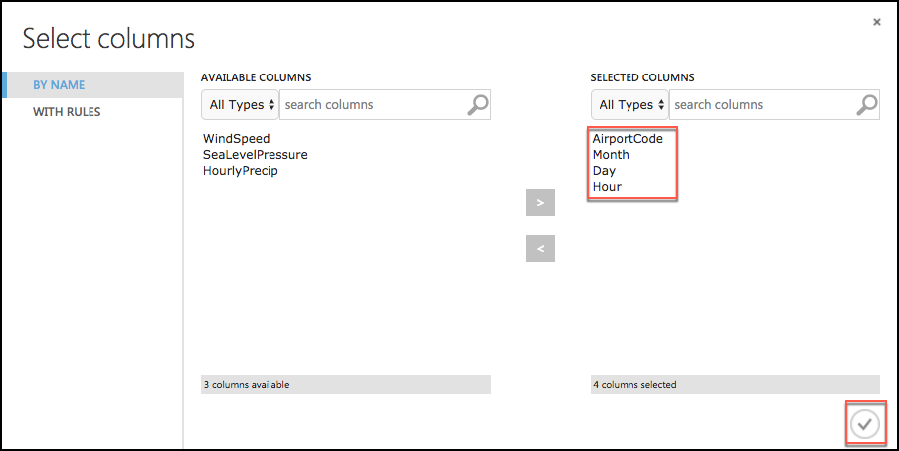
3. Leave the Join Type at Inner Join, and uncheck **Keep right key columns in joined table** (so that we do not include the redundant values of AirportCode, Month, Day, and Hour). 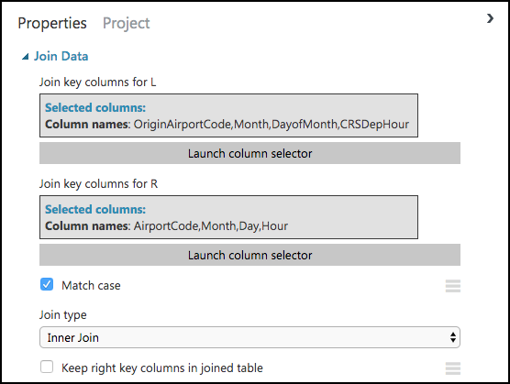
4. Next, drag an **Edit Metadata** module onto the design surface below the Join Data module, and connect its input port to the output port of the Join Data module. We will use this module to convert the fields that were unbounded String feature types, to the enumeration like Categorical feature.

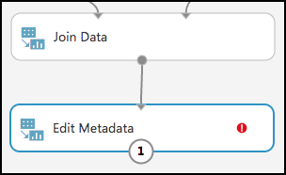

1. On the **Properties** panel of the Edit Metadata module, select **Launch column selector** and set the Selected columns to **DayOfWeek, Carrier, DestAirportCode, and OriginAirportCode**, and select the checkbox in the bottom right. 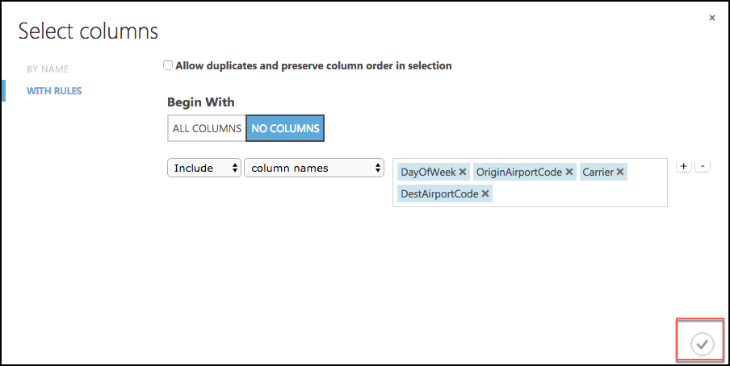
2. Set the Categorical drop down to **Make categorical**. 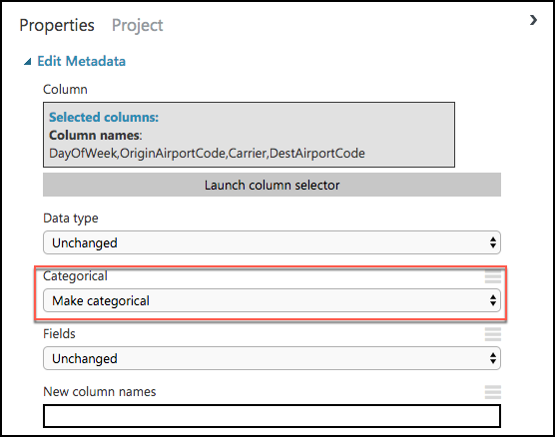
3. Drag a **Select Columns in Dataset** module onto the design surface, below the **Edit Metadata** module. Connect the output of the **Edit Metadata** module to the input of the **Select Columns** in Dataset module. 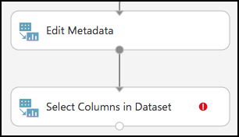
4. Launch the column selector, and choose **Begin With** **All Columns**, choose **Exclude** and set the selected columns to exclude: **OriginLatitude, OriginLongitude, DestLatitude**, and **DestLongitude**. 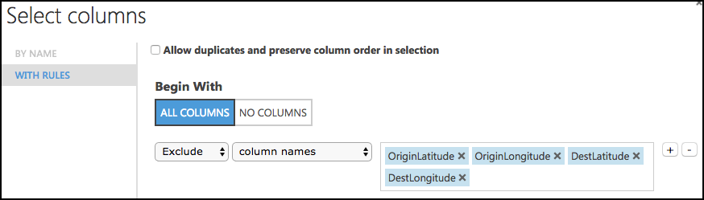
5. Save your experiment.
6. **Run** the experiment, to verify everything works as expected, and when completed select Visualize by right-clicking on the output of the **Select Columns in Dataset** module. You will see the joined datasets as output.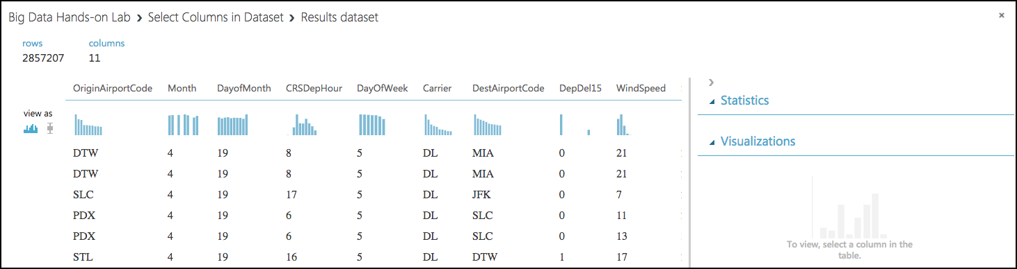
7. The model should now look like the following. 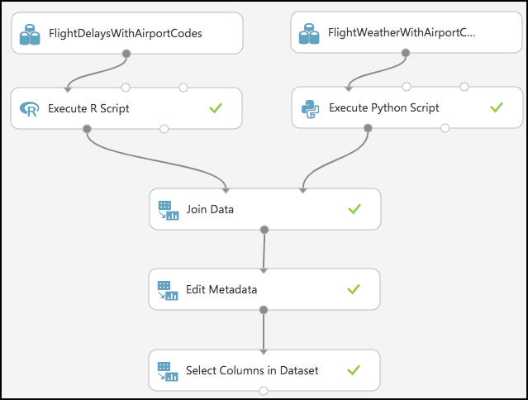

#### Task 7: Train the model

AdventureWorks Travel wants to build a model to predict if a departing flight will have a 15-minute or greater delay. In the historical data they have provided, the indicator for such a delay is found within the DepDel15 (where a value of 1 means delay, 0 means no delay). To create a model that predicts such a binary outcome, we can choose from the various Two-Class modules that Azure ML offers. For our purposes, we begin with a Two-Class Logistic Regression. This type of classification module needs to be first trained on sample data that includes the features important to making a prediction and must also include the actual historical outcome for those features.

The typical pattern is to split the historical data so a portion is shown to the model for training purposes, and another portion is reserved to test just how well the trained model performs against examples it has not seen before.

1. To create our training and validation datasets, drag a **Split Data** module beneath Select Columns in Dataset, and connect the output of the Select Columns in Dataset module to the input of the Split Data module. 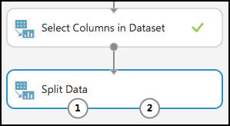
2. On the **Properties** panel for the Split Data module, set the Fraction of rows in the first output dataset to **0.7** (so 70% of the historical data will flow to output port 1). Set the Random seed to **7634**. 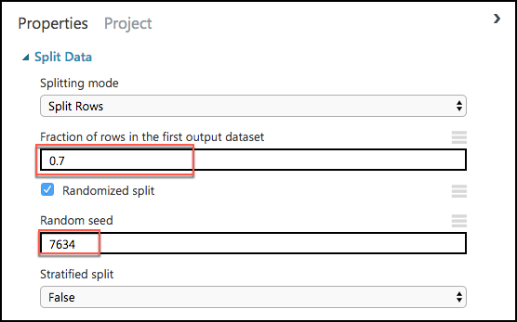
3. Next, add a Train Model module and connect it to output 1 of the Split Data module.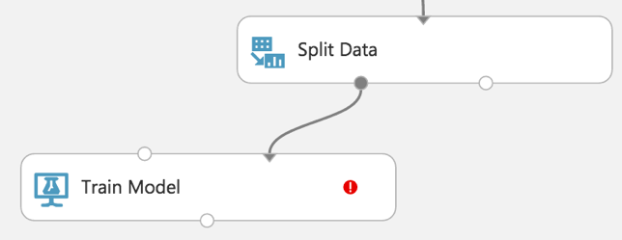
4. On the **Properties** panel for the Train Model module, set the Selected columns to **DepDel15**.

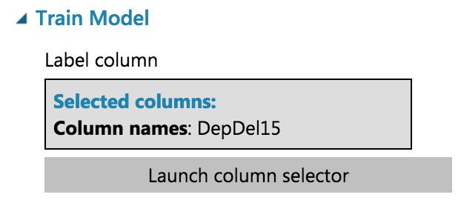

1. Drag a Two-Class Logistic Regression module above and to the left of the Train Model module and connect the output to the leftmost input of the Train Model module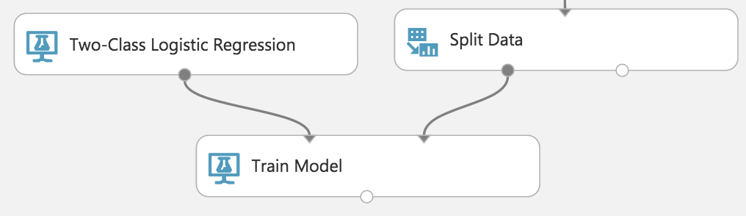
2. Below the Train Model drop a Score Model module. Connect the output of the Train Model module to the leftmost input port of the Score Model and connect the rightmost output of the Split Data module to the rightmost input of the Score Model.

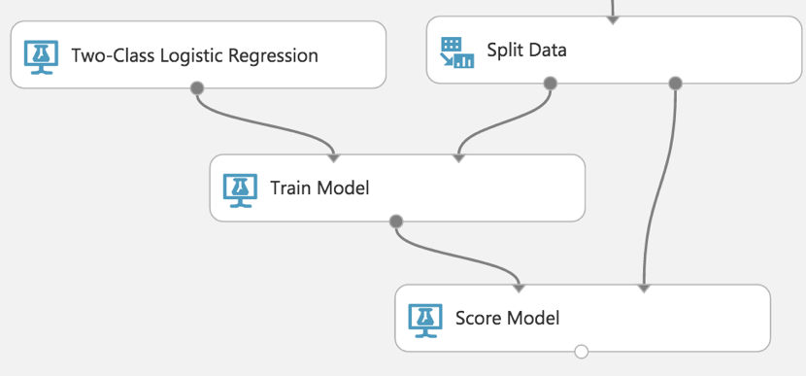

1. Save the experiment.
2. Run the experiment.
3. When the experiment is finished running (which takes a few minutes), right-click on the output port of the Score Model module and select **Visualize** to see the results of its predictions. **You should have a total of 13 columns**.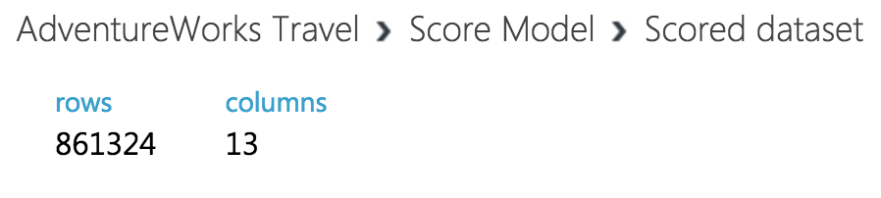
4. If you scroll to the right so that you can see the last two columns, observe there are Scored Labels and Scored Probabilities columns. The former is the prediction (1 for predicting delay, 0 for predicting no delay) and the latter is the probability of the prediction. In the following screenshot, **for example**, the last row shows a delay predication with a 53.1% probability.

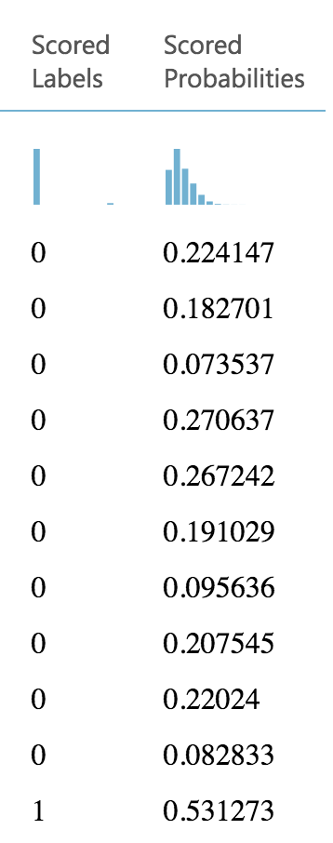

1. While this view enables you to see the prediction results for the first 100 rows, if you want to get more detailed statistics across the prediction results to evaluate your model's performance, you can use the **Evaluate Model** module.
2. Drag an **Evaluate Model** module on to the design surface beneath the **Score Model** module. Connect the output of the **Score Model** module to the leftmost input of the **Evaluate Model** module.

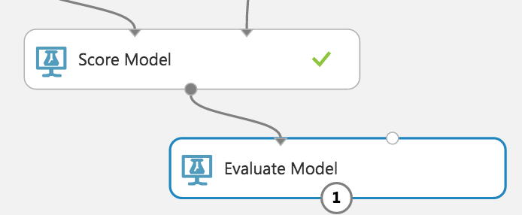

1. Run the experiment.
2. When the experiment is finished running, right-click the output of the **Evaluate Model** module and select **Visualize**. In this dialog box, you are presented with various ways to understand how your model is performing in the aggregate. While we will not cover how to interpret these results in detail, we can examine the ROC chart that tells us that at least our model (the blue curve) is performing better than random (the light gray straight line going from 0,0 to 1,1)—which is a good start for our first model!

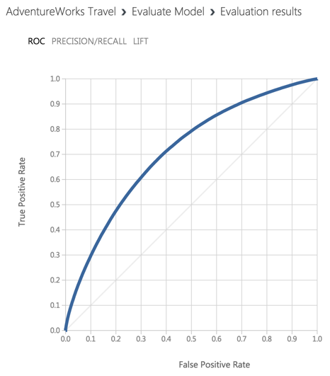

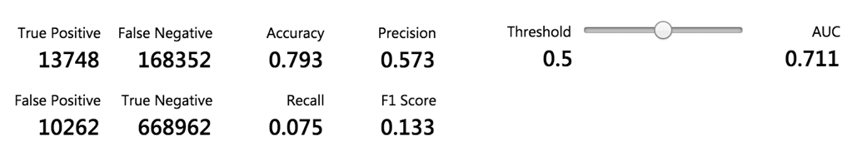

#### Task 8: Operationalize the experiment

1. Now that we have a functioning model, let us package it up into a predictive experiment that can be called as a web service.
2. In the command bar at the bottom, select **Set Up Web Service** and then select **Predictive Web Service [Recommended]**. (If Predictive Web Service is grayed out, run the experiment again) 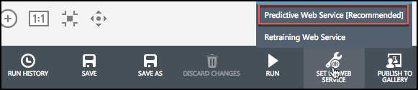
3. A copy of your training experiment is created, and a new tab labeled Predictive Experiment is added, which contains the trained model wrapped between web service input (e.g. the web service action you invoke with parameters) and web service output modules (e.g., how the result of scoring the parameters are returned). 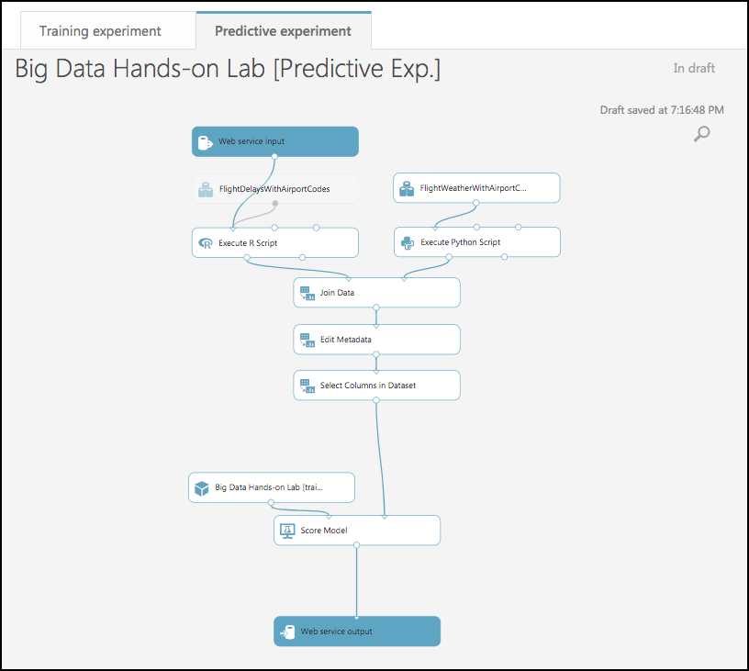
4. We will make some adjustments to the web service input and output modules to control the parameters we require and the results we return.
5. Disconnect the output from the **Web service input** module from the **Execute R Script** (HINT: Select the connecting line, and hit the Delete key OR Right click on the connecting line, and choose Delete)
6. Move the **Web service input** module down, so it is to the right of the **Join Data** module.
7. Connect the output of the **Web service input** module to input of the **Edit Metadata** module.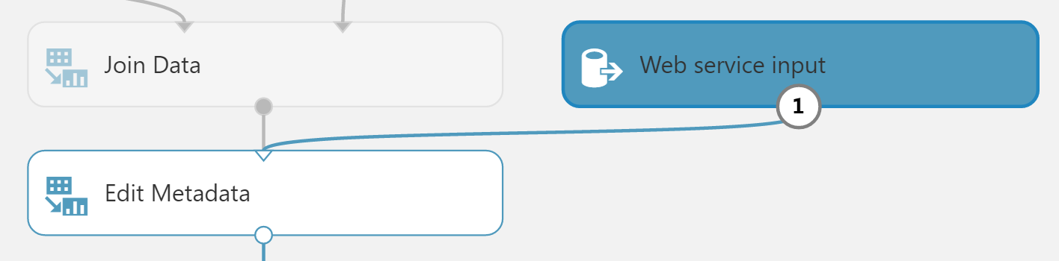
8. Right-click the line connecting the **Join Data** module and the **Edit Metadata** module and select **Delete**. Move the Edit Metadata Module down a little to give yourself more room.

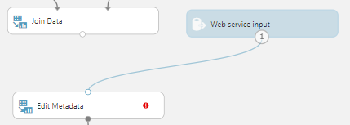

1. In between the **Join Data** and the **Edit Metadata** modules, drop a **Select Columns in Dataset module**. Connect the **Join Data** module’s output to the **Select Columns** module’s input, and the **Select Columns** output to the Edit Metadata module’s input.

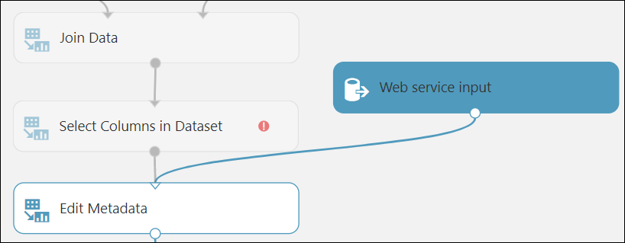

1. Click the **Select Columns in Dataset module**, and in the **Properties** panel click **Launch column select. In the Select column** dialog select **All Columns** for Begin With and then select **Exclude**. Enter columns **DepDel15, OriginLatitude, OriginLongitude, DestLatitude,** and **DestLongitude**. This configuration will update the web service metadata so that this column does not appear as a required input parameter for the web service.

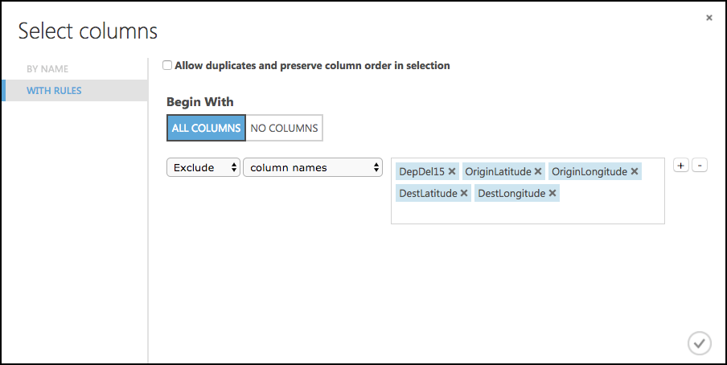

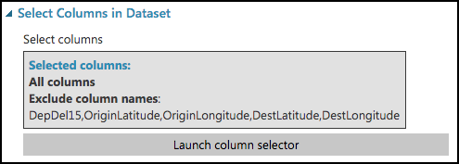

1. Select the **Select Columns in Dataset** module that comes after the **Edit Metadata** module, and delete it as we are doing that in the previous step now.
2. Connect the output of the **Edit Metadata** module directly to the right input of the Score Model module.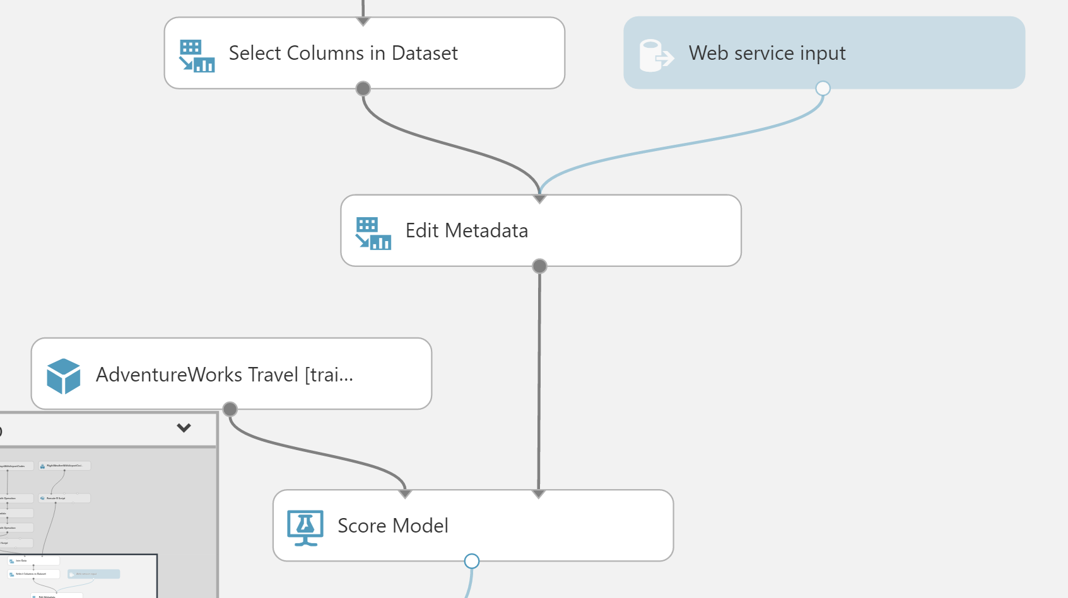
3. As we removed the latitude and longitude columns from the dataset to so they would not be required as input to the web service, we have to add them back in so that the results can be easily visualized on a map. We are going to always show the Origin Airport on the map, so will do a lookup to a location table based on the Origin Airport Code.
4. To add these fields back, begin by deleting the line between the **Score Model** and **Web service output**.

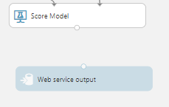

1. Drag the **AirportCodeLocationLookupClean** dataset on to the design surface, positioning it below and to the right of the Score Model module.

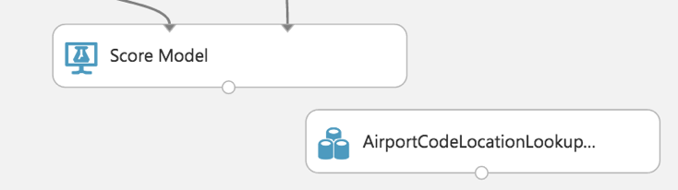

1. Add a **Join Data** module, and position it below and to the left of the **AirportCodeLocationLookupClean** module.

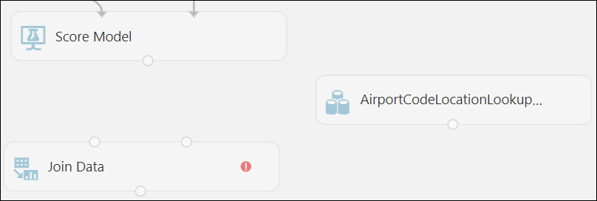

1. Connect the output of the **Score Model** module to the leftmost input of the **Join Data** module and the output of the **AirportCodeLocationLookupClean** to the rightmost input of the **AirportCodeLocationLookupClean** module.

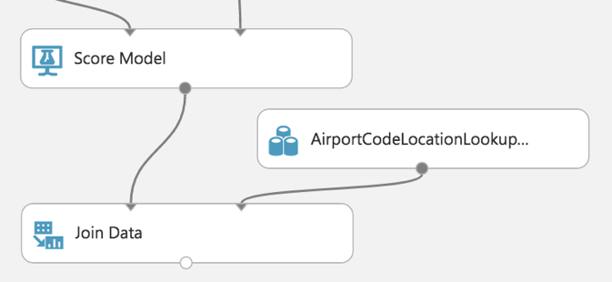

1. Click the **Join Data** module, and in the **Properties** panel for the **Join key columns for L** launch the column selector and then under Begin With choose **No Columns** and set the Include column names to **OriginAirportCode,** then click the Check to confirm.

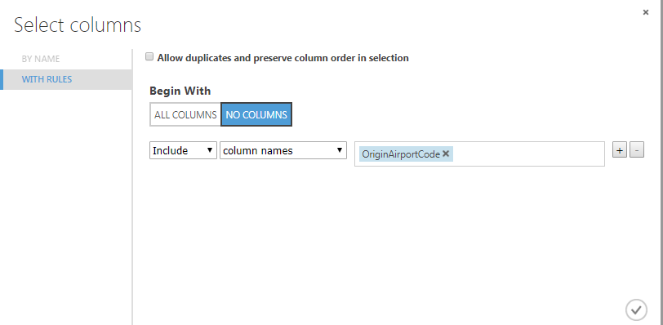

1. For the **Join key columns for R**, launch the column selector move **AIRPORT** over to the Selected Column side and click the Check to confirm. Then, uncheck **Keep right key columns** in joined table.

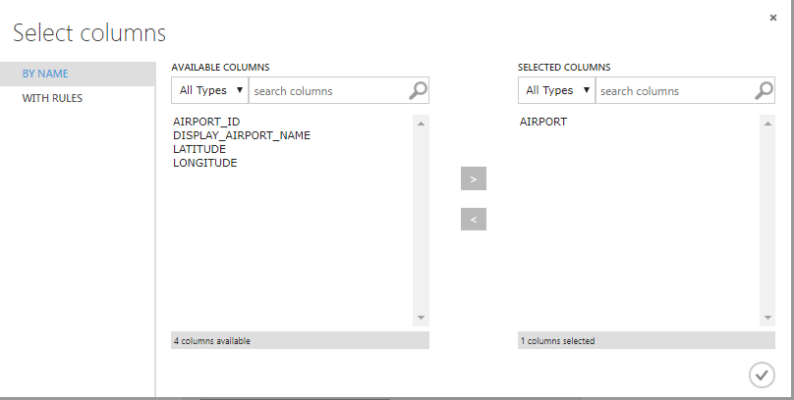

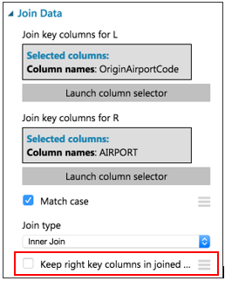

1. Add an **Execute R Script** module beneath the **Join Data** module. Connect the **Join Data** output to the leftmost input of the **Execute R Script** module.

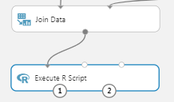

1. Replace the default script in the **Execute R Script** module with the following and click the checkmark to save it. This script removes columns we don't need to display and renames the latitude and longitude that we looked up to clarify that it is for the Origin Airport.

ds.theresults <- maml.mapInputPort(1)

# remove a couple of columns we don't need to include in output results

ds.theresults$AIRPORT_ID <- NULL

ds.theresults$DISPLAY_AIRPORT_NAME <- NULL

# rename the columns we looked up to clarify which airport (Origin) we are showing

colnames(ds.theresults)[colnames(ds.theresults) == 'LATITUDE'] <- 'OriginLatitude'

colnames(ds.theresults)[colnames(ds.theresults) == 'LONGITUDE'] <- 'OriginLongitude'

maml.mapOutputPort("ds.theresults");

1. Connect the leftmost output of the **Execute R Script** module to the input of the **Web service output** module.

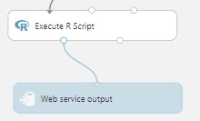

1. Run the Experiment. This may take a few minutes. Your experiment is now ready to be deployed as a web service!

#### Task 9: Deploy Web Service and Note API Information

1. When the experiment is finished running, select **Deploy Web Service [New]** (do **not** choose [Classic]). This will launch the web service deployment wizard.

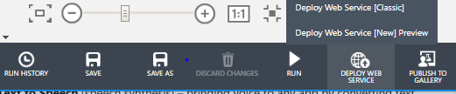

1. You will be taken to the Microsoft Azure Machine Learning Web Services page to complete the configuration.
2. You can leave the default name, and storage account should be selected. Select **Create new...** for **Price Plan** and then provide a **Plan Name** value. Finally, under **Monthly Plan Options** select **Standard DevTest**.

**NOTE:** If you have already created a DevTest plan, you will not be able to create another one. You can simply select the DevTest plan that was already created from the **Price Plan** dropdown box.

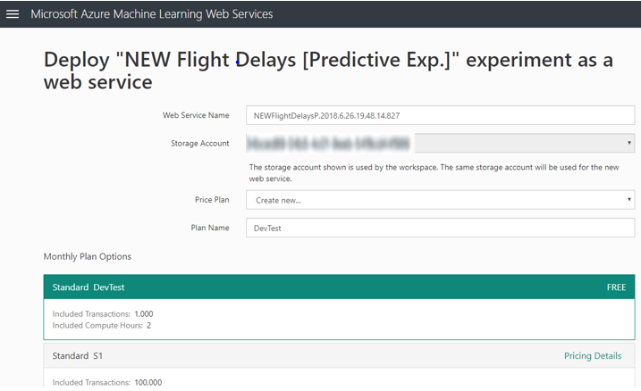

1. Scroll down and click the **Deploy** button. After deployment is completed (the button will change to say **Processing…**), you will be taken to the web services **Quick Start** page for your new web service.

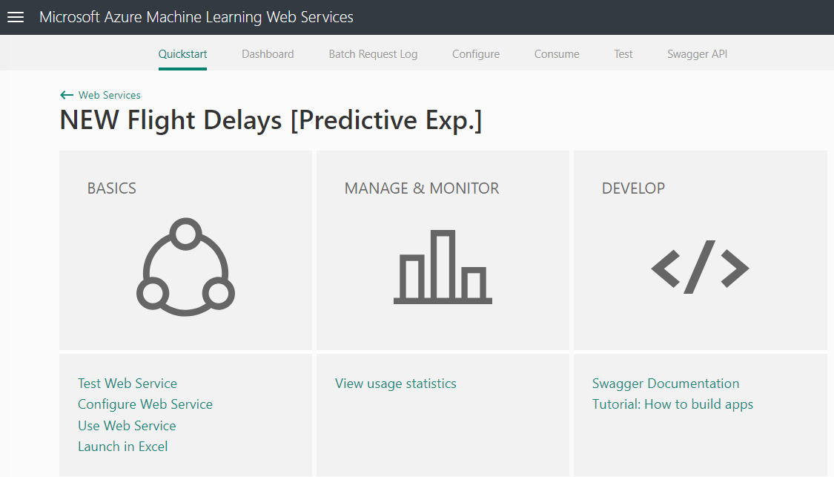

1. From the **Quick Start** page, click the **Use Web Service** link. You will get to a screen similar to the following (some of the identifying information is obscured in the pictures below). Follow the next few steps to get the key information you will need to access this web service.

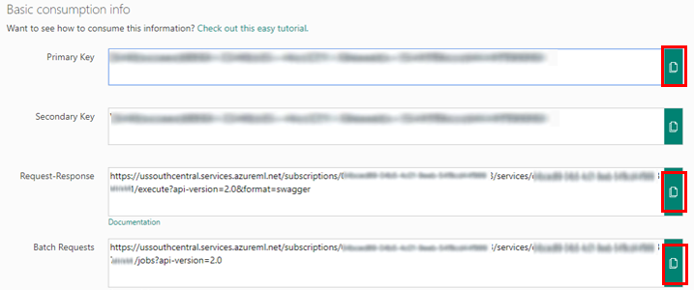

1. Click the Copy button for the **Primary key**, open a copy of Notepad, and paste the value in the editor.
2. Click the Copy button for the **Request-Response** link. The URL will look something like the following:

[https://ussouthcentral.services.azureml.net/subscriptions/[*SOME_GUID*]/services/*[SOME_OTHER_GUID*]/execute?api-version=2.0&format=swagger](https://ussouthcentral.services.azureml.net/subscriptions/%5bSOME_GUID%5d/services/%5bSOME_OTHER_GUID%5d/execute?api-version=2.0&format=swagger)

1. The first GUID after subscriptions is your Workspace ID. The second GUID after services is your Service ID. Copy each of these values into Notepad. Make sure you note which GUID is which because you will need these in a later step.
2. Finally, copy the **Batch Requests** URL to Notepad as well, but make sure to remove the '?' character and everything after it. You should be left with a URL that looks something like the following. Again, make sure to label this as your batch service in your Notepad instance.

[https://ussouthcentral.services.azureml.net/subscriptions/[*SOME_GUID*]/services/[*SOME_OTHER_GUID*]/jobs](https://ussouthcentral.services.azureml.net/subscriptions/%5bSOME_GUID%5d/services/%5bSOME_OTHER_GUID%5d/jobs)

## Exercise 2: Deploy intelligent web app

Duration: 20 minutes

In this exercise, you will deploy an intelligent web application to Azure from GitHub. This application leverages the operationalized machine learning model that was deployed in Exercise 1 to bring action-oriented insight to an already existing business process.

If you were not able to complete all of Exercise 1, please see Appendix A for an alternative method to setup the Azure Machine Learning Service model you can use for completing the rest of the exercises in this lab.

#### Task 1: Deploy web app from GitHub

1. Navigate to <https://github.com/chmitch/ocp-big-data-and-visualization/blob/master/AdventureWorksTravel/README.md> in your browser of choice, but where you are already authenticated to the Azure portal.
2. Read through the README information on the GitHub page.
3. Click the **Deploy to Azure** button on that page.



1. On the following page, ensure the fields are populated correctly.
   1. Ensure the correct Directory and Subscription are selected.
   2. Select the Resource Group that you have been using throughout this lab.
   3. Either keep the default Site name, or provide one that is globally unique, and then choose a Site Location.
   4. Finally, enter the ML API and Weather API information.
      1. Recall that you recorded the ML API information back in Exercise 1, Task 9, but if you need to look it up again follow the next few steps.
         1. This information can be obtained on your Machine Learning web service page (<https://services.azureml.net>), login, then select “Web Services” menu and select your service. From there, select the “Consume” menu.
         2. The Primary API Key listed is your ML API key
         3. In the Request-Response URL, the GUID after workspaces/ is your ML Workspace Id
         4. In the Request-Response URL, the GUID after services/ is your ML Service Id

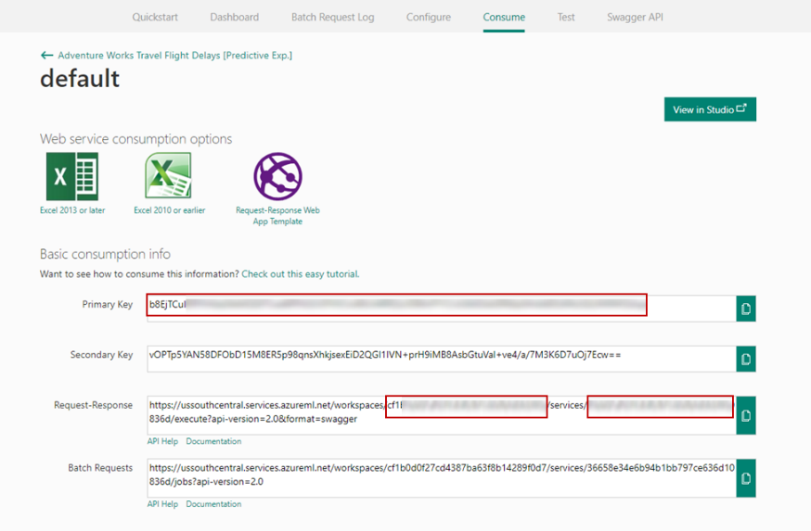

* 1. Also, recall that you obtained the Weather API key back in the Task 3 of the prerequisite steps for the lab. Insert that key into the Weather Api Key field.

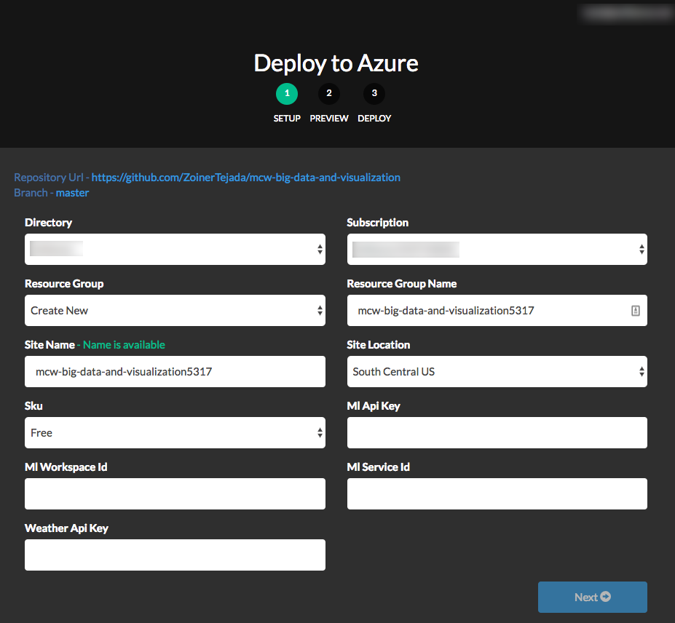

1. Select **Next**, and on the following screen, select **Deploy**.
2. The page should begin deploying your application while showing you a status of what is currently happening.

**Note**: If you run into errors during the deployment that indicate a bad request or unauthorized, verify that the user you are logged into the portal with an account that is either a Service Administrator or a Co-Administrator. You won’t have permissions to deploy the website otherwise.

1. After a short time, the deployment will complete, and you will be presented with a link to your newly deployed web application. CTRL+Click to open it in a new tab.
2. Try a few different combinations of origin, destination, date, and time in the application. The information you are shown is the result of both the ML API you published, as well as information retrieved from the Weather Underground API. NOTE: If you get an error about the Forecast API, try adjusting the date to tomorrow’s date and rerun.
3. Congratulations! You have built and deployed an intelligent system to Azure.

## Exercise 3: Setup Azure Data Factory

Duration: 20 minutes

In this exercise, attendees will create a baseline environment for Azure Data Factory development for further operationalization of data movement and processing. You will create a Data Factory service in this section.

#### Task 1: Connect to the Lab VM

1. **Note**: If you are already, connected to your Lab VM, skip to Task 2.
2. From the left side menu in the Azure portal, click on **Resource groups**, then enter your resource group name into the filter box, and select it from the list. 
3. Next, select your lab virtual machine from the list. 
4. On your Lab VM blade, select **Connect** from the top menu. 
5. Download and open the RDP file.
6. Select Connect, and enter the following credentials:
   * User name: demouser
   * Password: Password.1!!

#### Task 2: Download and stage data to be processed

In this task, you will setup two containers in your storage account, one will contain a set of flights and weather data that will be scored in batch using the flight delay machine learning model. The results of the scoring will be stored as a file in the second container.

1. Once you have logged into the Lab VM, create a new folder called **C:\Data**.
2. Open a web browser.
3. Download the AdventureWorks sample data from [Training Data](https://github.com/chmitch/ocp-big-data-and-visualization/blob/master/Data/FlightsAndWeatherInput.csv) (NOTE: to download from Github in the browser, right click on the Download button, then select **Save Link as…**) and save it to **C:\Data** as **FlightsAndWeatherInput.csv**
4. From a browser window on the VM navigate to the Azure portal (<https://portal.azure.com>). From the left side menu in the Azure portal, click on **Resource groups**, then enter your resource group name into the filter box, and select it from the list.
5. Next, select the sparkstorage storage account that is prefixed with the App name you provided in the pre-lab setup.

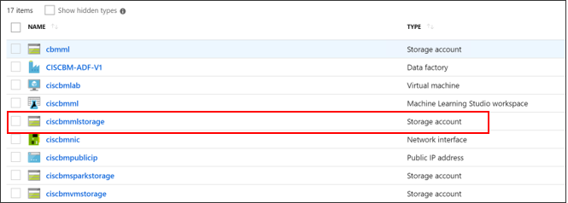

1. Select **Blobs** in the Services section (or

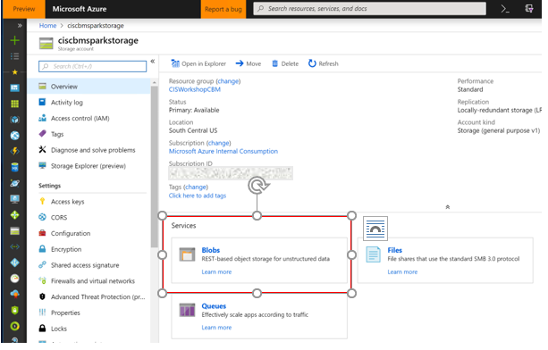

1. Create a new container, by selecting the **“+ Container”** option

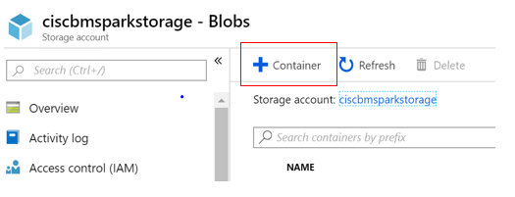

1. Enter the name “flightsandweather” and select “Private” for the public access level, then select “**OK**”.

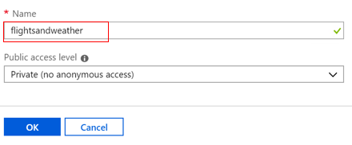

1. Add another container by selecting the **“+ Container”** option again. Name this one “scoredflights” and select “Private” for the public access level, then select “**OK**”

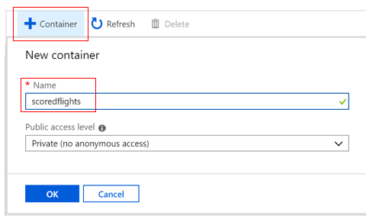

1. Next, you will upload one of the data files from step 3 to “flightsandweather” – in the next exercise, this file will be scored in batch by the machine learning model using Azure Data Factory. Select the “flightsandweather” container.

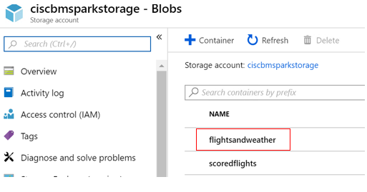

1. Select the **Upload** option. This will bring up the “Upload blob” blade.

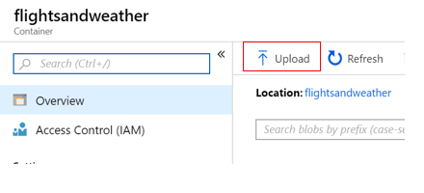

1. Select the file upload button, then browse to **C:\Data\** and select the **FlightsAndWeatherInput.csv** file. Select the **Upload** button that should be enabled once you’ve selected the file.

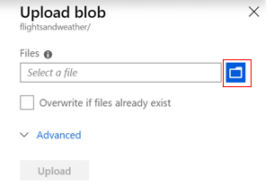

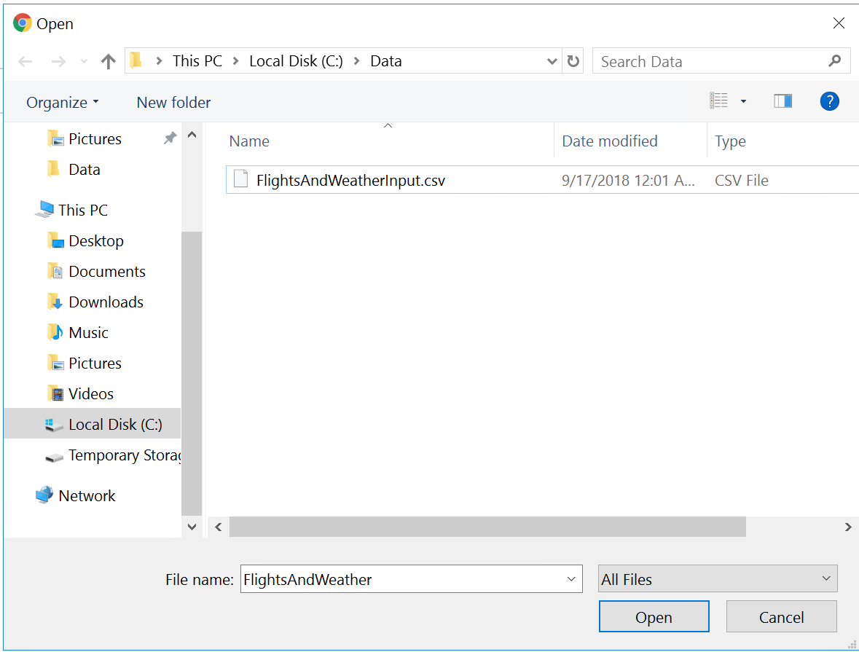

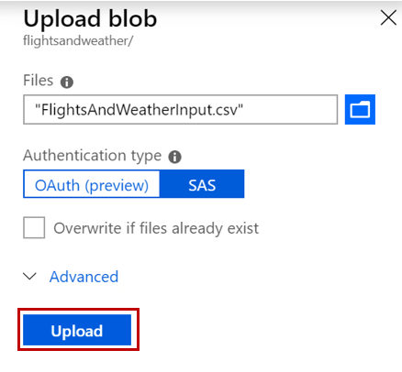

1. You should see a notification that the file upload completed, and you will see it in the container.

#### Task 3: Create an Azure Data Factory

1. If you aren’t already there, open a browser window and navigate to the Azure portal (<https://portal.azure.com>). Once prompted, log in with your Microsoft Azure credentials.
2. From the top left corner of the Azure portal, select **+ Create a resource**, and select **Analytics**, then select **Data Factory**.

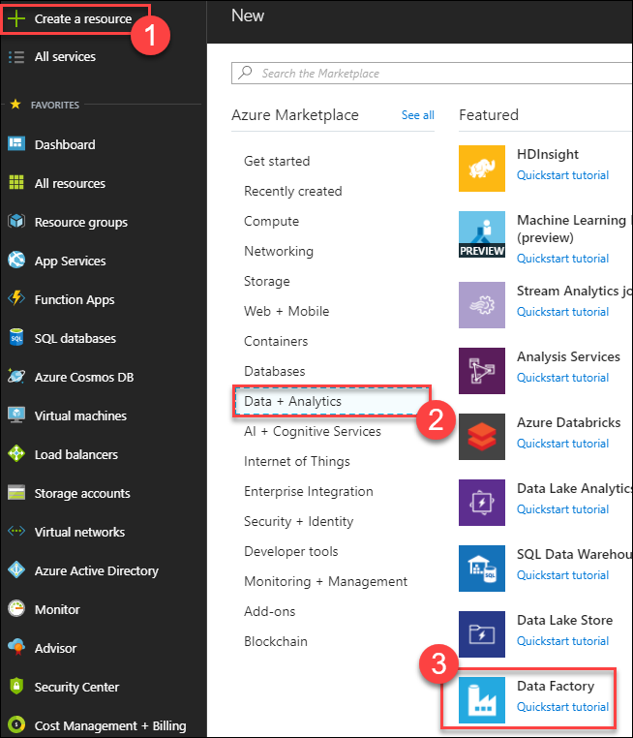

1. On the New data factory blade, enter the following:
   1. Name: **Provide a new unique name, alpha-numeric 3-24 characters lowercase (this is a dns name)**
   2. Subscription: **Select your subscription**
   3. Resource Group: **Choose Use existing, and select the Resource Group you created when deploying the lab prerequisites**
   4. Version: **Select V2**
   5. Location: **Select one of the available locations from the list nearest the one used by your Resource Group**
   6. Select **Create**

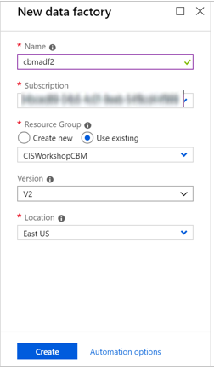

1. Once the deployment is completed, you will receive a notification that it succeeded.

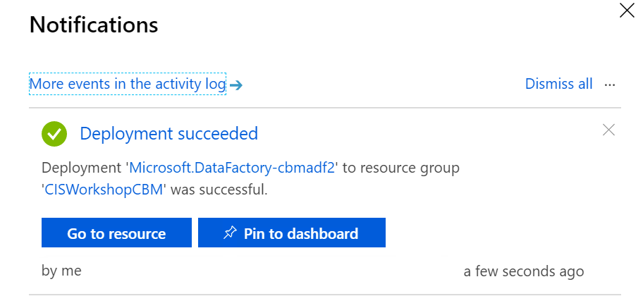

## Exercise 4: Operationalize ML scoring with Azure ML and Data Factory

Duration: 20 minutes

In this exercise, you will use the Data Factory to operationalize the scoring of data in batch using the previously created Azure Machine Learning (ML) model.

#### Task 1: Create Azure Blob Storage Linked Service

1. Return to the Azure Data Factory blade in the Azure portal
2. Select **Author & Monitor** below **Quick links**.

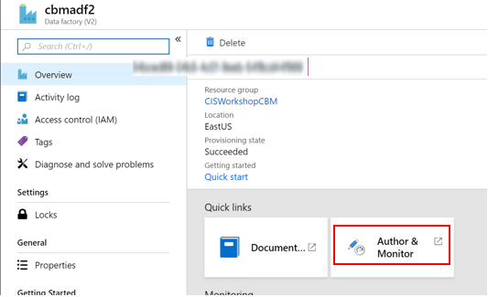

1. On the **Let’s get started** window, switch to the **Author** tab in the left panel.

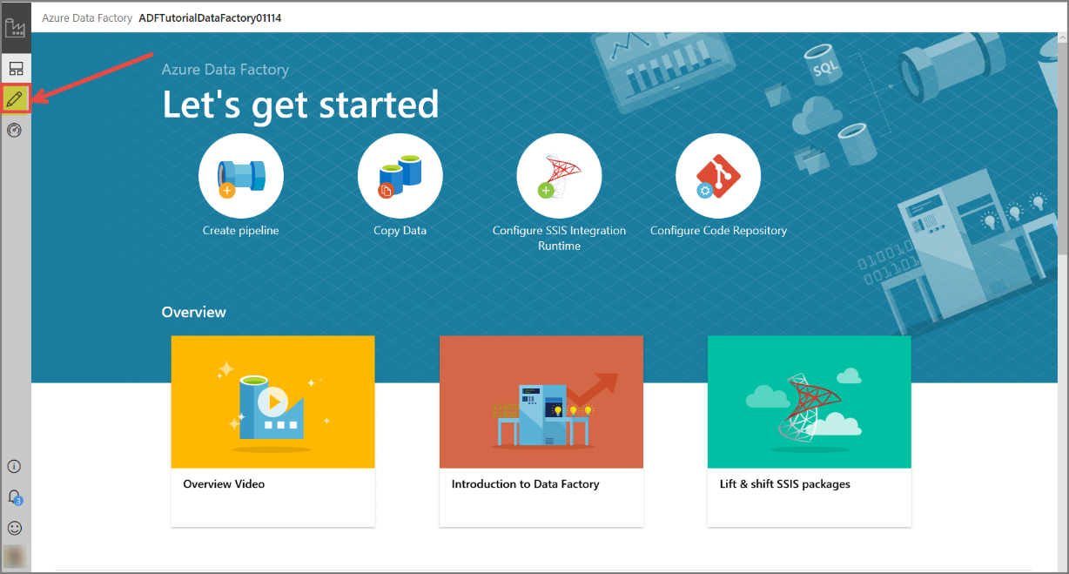

1. On the Author blade, select **Connections**, and then select the **New** button.

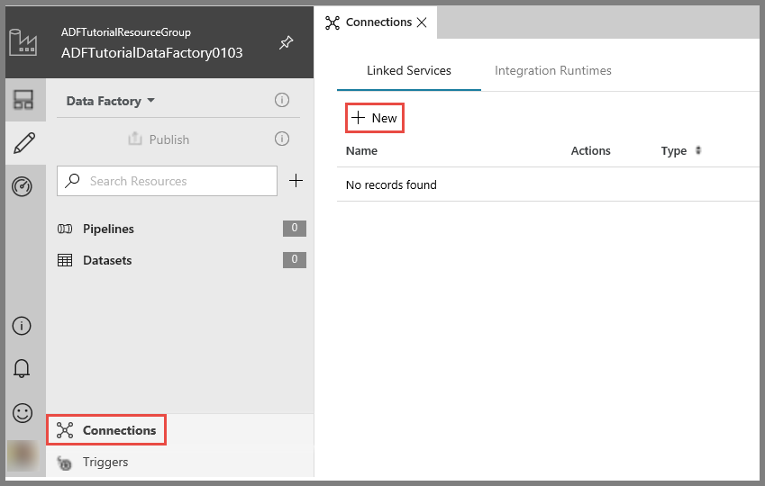

1. On the **New Linked Service** page, select **Azure Blob Storage**, and then select **Continue**.

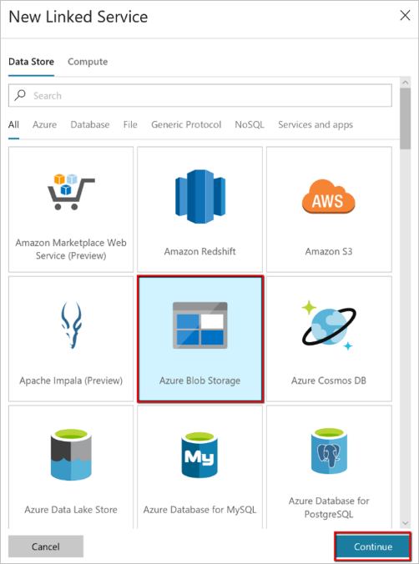

1. Complete the following:
   1. **Name**: AzureStorageLinkedService
   2. **Storage account name**: the storage account you uploaded your files to, that will be “sparkstorage” with your app name prefix.
   3. Select **Test Connection**. You should see a “Connection successful” message. Then select **Finish.**

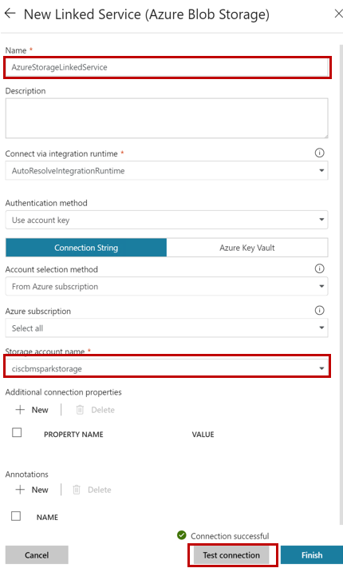

1. You’ll see a notification that the AzureStorageLinkedService has been saved. Dismiss this and you should return to the Connection screen with your new linked service.

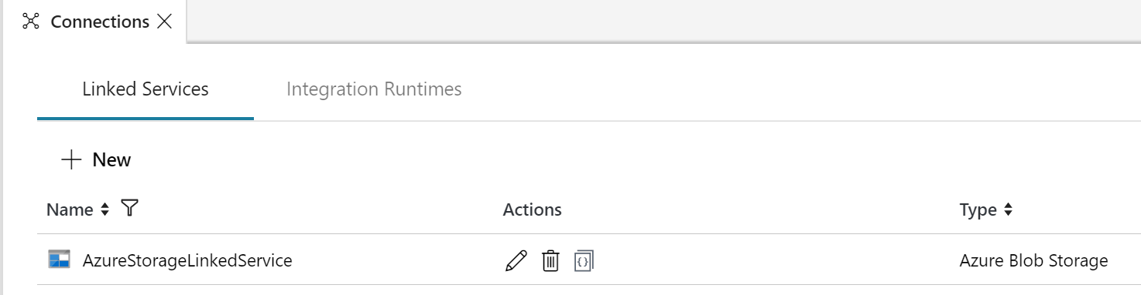

#### Task 2: Create Azure AML Linked Service

In this section you will configure a Linked Service to the web service created in Azure Machine Learning.

1. On the Author blade, select **Connections**, and then select the **New** button.



1. On the **New Linked Service** page, select **Compute**, **then Azure ML**, and then select **Continue**.

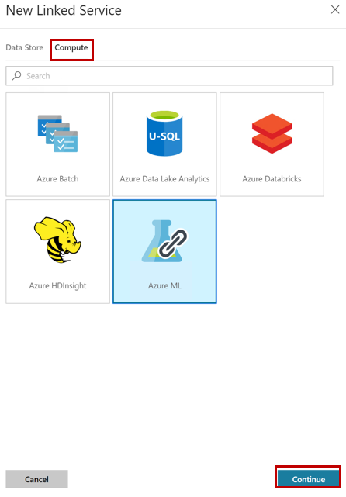

1. On the New Linked Service (Azure ML) blade, enter the following:
   1. Name: **AzureMLLinkedService**
   2. End Point: The value of **End Point** is your web service’s **Batch Request URL,** remember to ***remove*** the query string (e.g., “?api_version=2.0”).
   3. API Key is the **API Key** of your machine learning web service.
   4. Select **Test Connection**. You should see a “Connection successful” message. Then select **Finish.**

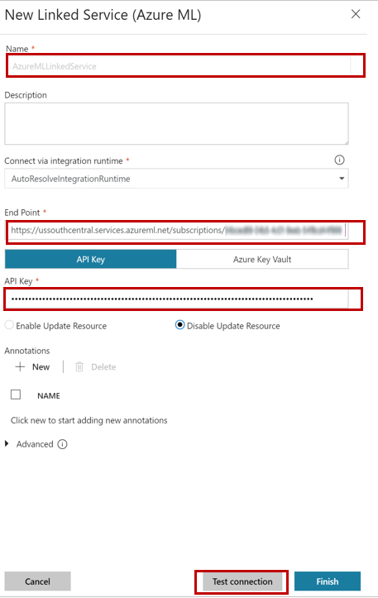

1. Once it has been created, select the **Publish All** option. You should now see both of your linked services.

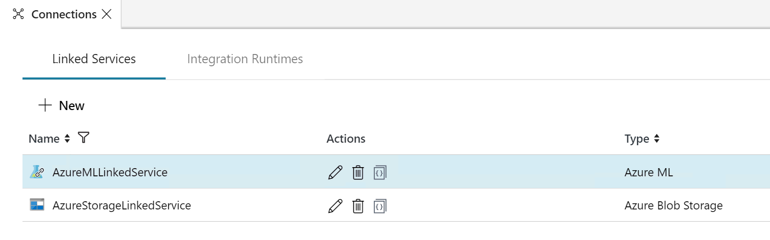

#### Task 3: Create a Pipeline

In this task, you will create a pipeline using the linked services you setup to run a Batch Machine Learning activity.

1. Select the **+** (plus) button, and then select **Pipeline**.

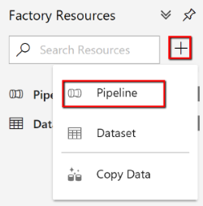

1. In the General tab, specify **Batch Scoring** for **Name**.

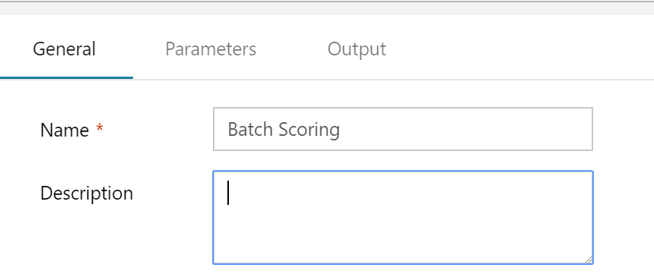

1. Under **Machine Learning,** select **ML Batch Execution** and drag it onto the canvas to the right.

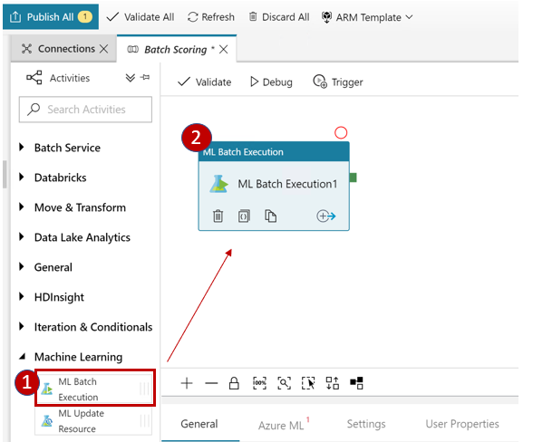

1. On the General tab below the canvas, first enter the **Name** of **Batch Score Flights**.

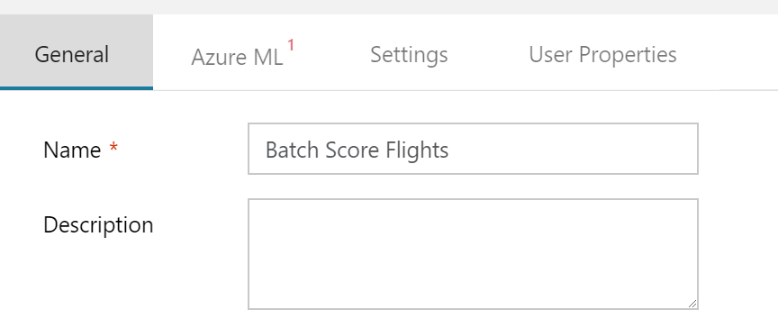

1. On the **Azure ML** tab, Select the **AzureMLLinkedService**.

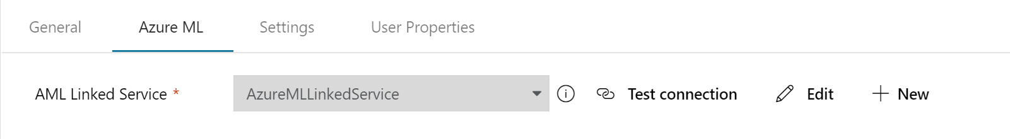

1. On the **Settings** tab, expand **Web Service Inputs** and select **New.**

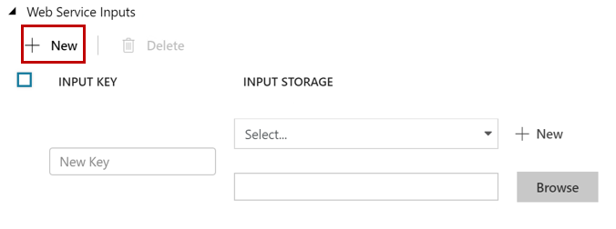

1. Enter the following:
   1. Replace **New Key**  with the name **Input1**
   2. Select the **AzureStorageLinkedService**
   3. Browse to the **FlightsAndWeatherInput.csv** file in the flightsandweather container.
   4. Once you’ve entered the information, you can close the **Web Service Inputs** section.

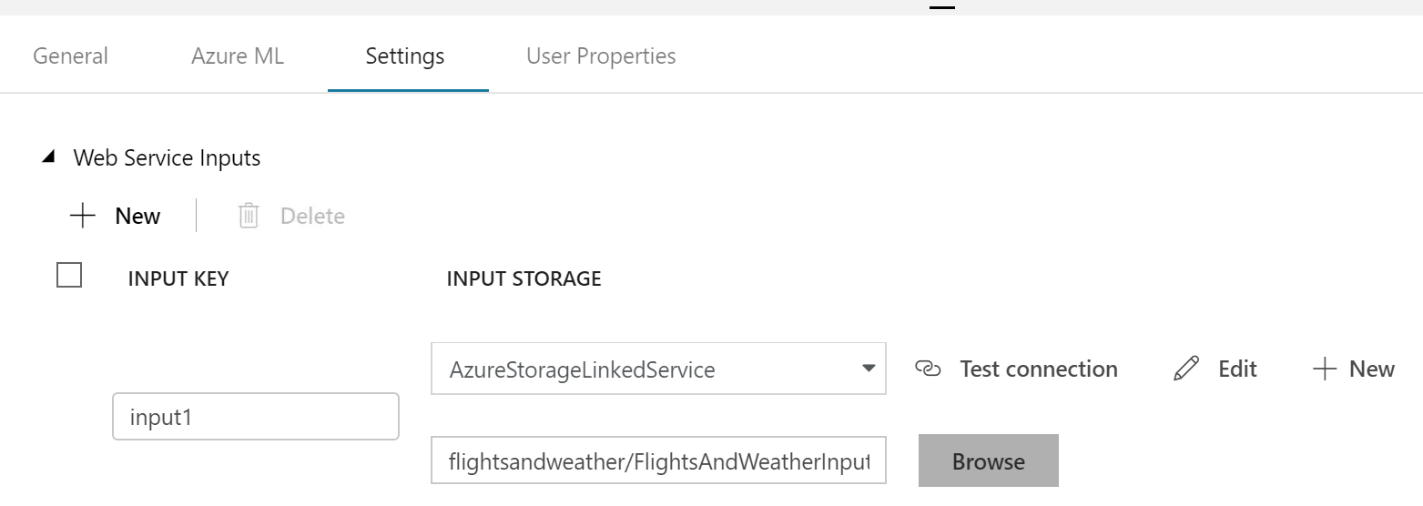

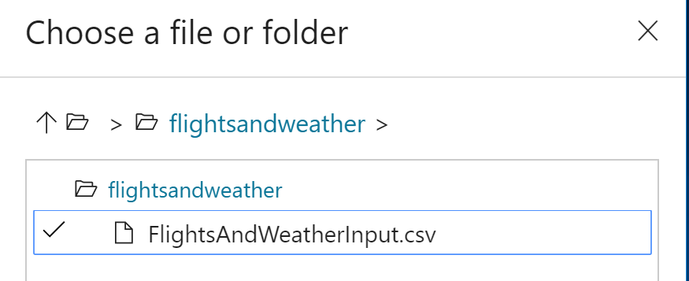

1. Expand the **Web Service Outputs** section, and Select **New.**

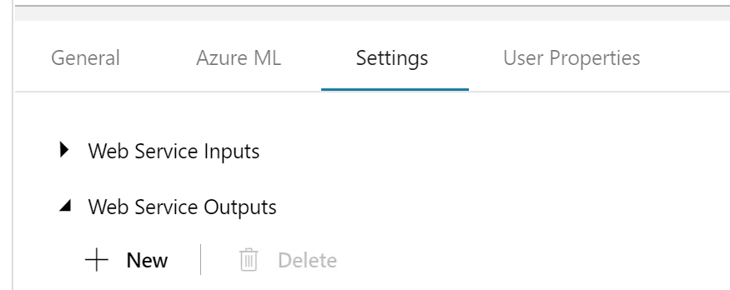

1. Enter the following:
   1. Over write **Key Name** with **output1**
   2. Select the **AzureStorageLinkedService**.
   3. In the file path/name box – this time don’t browse, but type the following in: **scoredflights/scoredflights.csv** (this file will be created when the service runs).
   4. You can close the Web Service Outputs section.

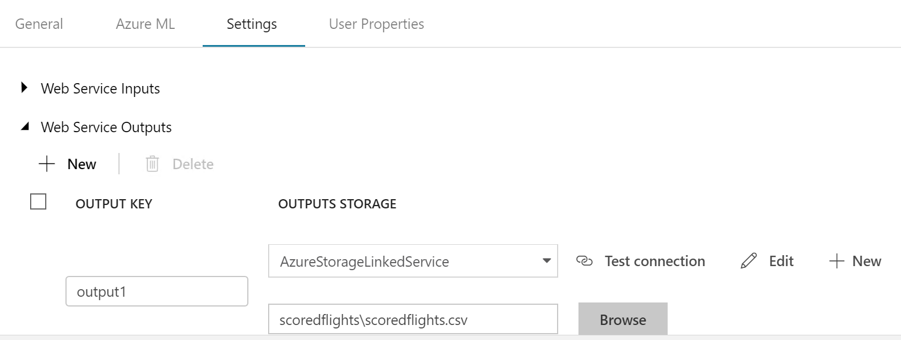

1. Select **Validate** at the top of the screen, then **Publish All.**

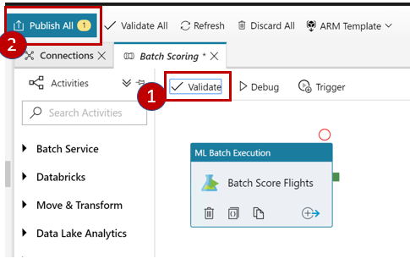

1. Once publishing is complete, you will see a notification.

#### Task 4: Run & Monitor pipeline activities

In this next section we will run and monitor the pipeline.

1. From the **Batch Scoring** pipeline window, select the **Trigger** option, then select **Trigger Now** to run the pipeline on demand.

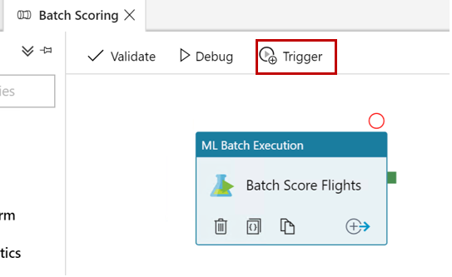

1. A **Pipeline Run** screen will launch, we don’t need to enter any parameters, so just select **Finish.** You will see a notification that the pipeline is running.
2. Go to the **Monitor** option on the left panel.

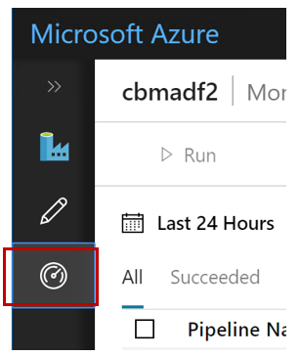

1. From the Pipeline Runs list you should see **Batch Scoring** and the status of **In Progress**

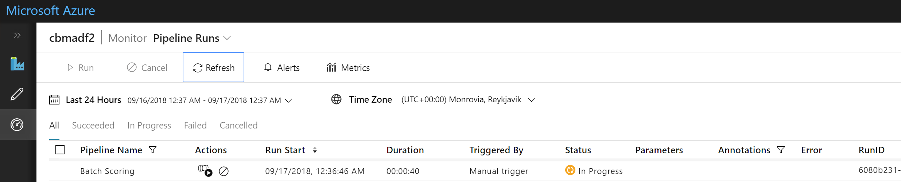

1. Once the run completes the status will change to **Succeeded.** You’ve now successfully scored a batch of flight records for likelihood of a delay. In the next sections we will work with this file to view.

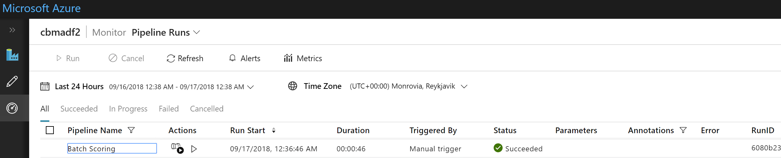

## Exercise 5: Summarize data using Databricks

Duration: 20 minutes

In this exercise, you will prepare a summary of flight delay data in Databricks using Spark SQL.

If you were not able to complete all of Exercise 3 & 4 (Setup Azure Data Factory & Operationalize ML Scoring with Azure ML and Data Factory), please see Appendix B for an alternative method to setup for the next sections.

#### Task 1: Login to the Databricks portal and ensure your cluster is running

In this task, you will connect to your databricks cluster and create a new data import notebook.

1. In the Azure portal, navigate to your Databricks cluster, and from the Overview blade select “Launch Workspace”. 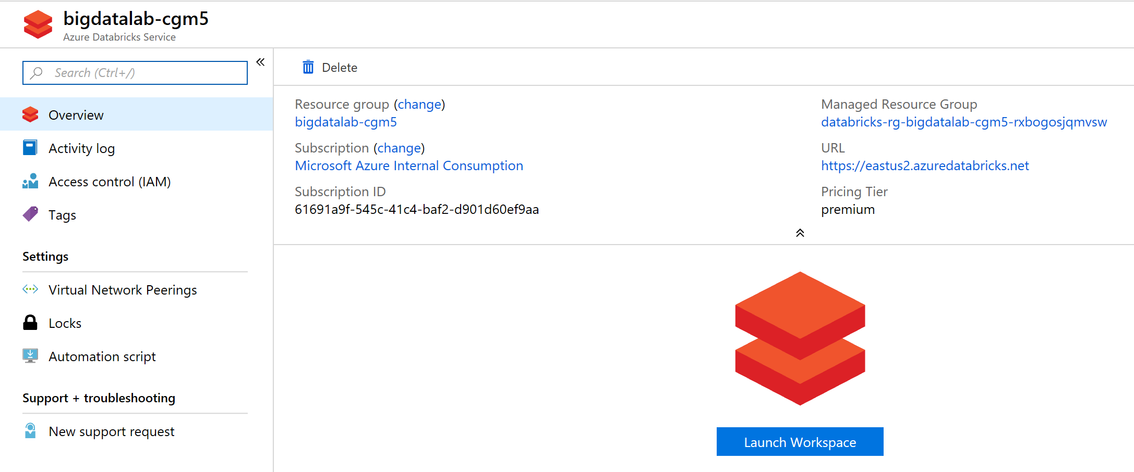
2. With the default configuration that we used in creating our clusters, Databricks will deprovision your cluster after 2 hours of inactivity. We need to ensure our cluster is still running. On the left navigation click on “Clusters”  
   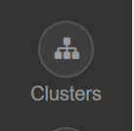
3. If your cluster status says “Terminated” it needs to be started. If your cluster is in a “Running” state you can skip to Task 2.  
   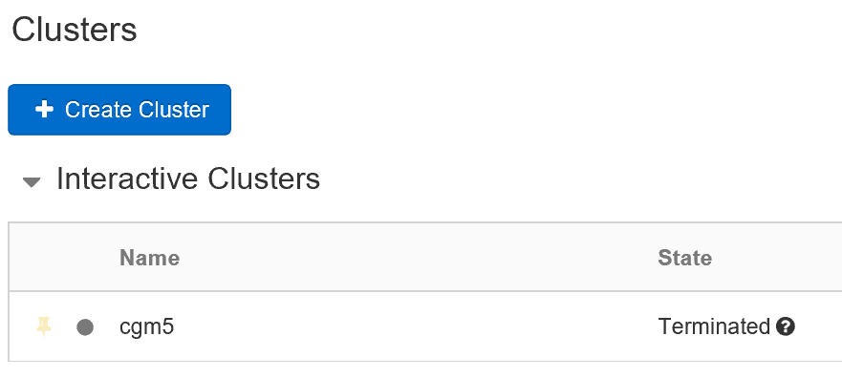
4. Click on the start button for the cluster.  
   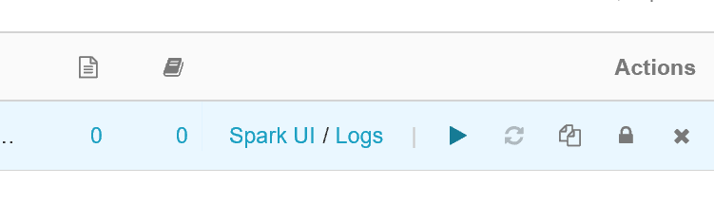
5. Your cluster will enter a “Pending” state and eventually will reach a “Running” state. (Note: this process takes 2-3 minutes).  
     
   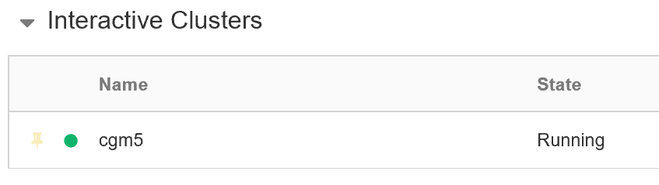

#### Task 2: Summarize delays by airport

Now that our cluster is running, we need to work with the scored flight data. If you recall the scored data was stored to blob storage. In this task we will connect data bricks to the scored data in blob storage and manipulate the data to support our reporting needs.

1. In the Databricks management portal, navigate to the “Data” area in the left navigation.  
   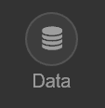
2. Select “Add Data”, which will bring you to the “Create New Table” dialogue.
3. Select “Other Data Sources” and “Azure Blob Storage” for the connector. Finally click “Create Table in Notebook”.  
   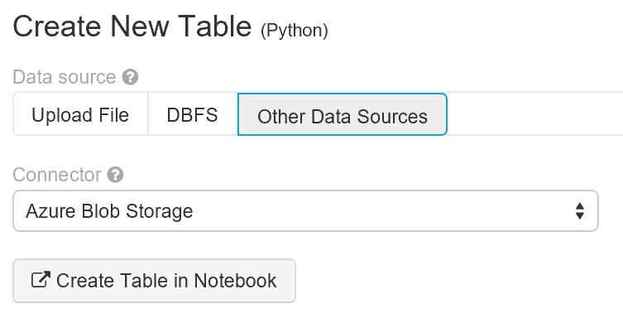
4. You will be presented a template Databricks notebook for working with Azure Blob Storage. The next several steps will configure this notebook to connect to our scored data in blob storage, and create Spark tables.
5. On the initial Notebook screen, first attach the notebook to your cluster by clicking on “Detached” and selecting your cluster from the drop down list.  
   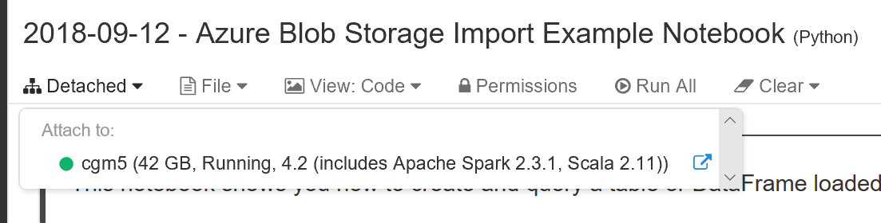
6. Step one in the notebook is made up of three cells (Cmd 3, Cmd 4 and Cmd 5) which initialize the details of the storage account.  
   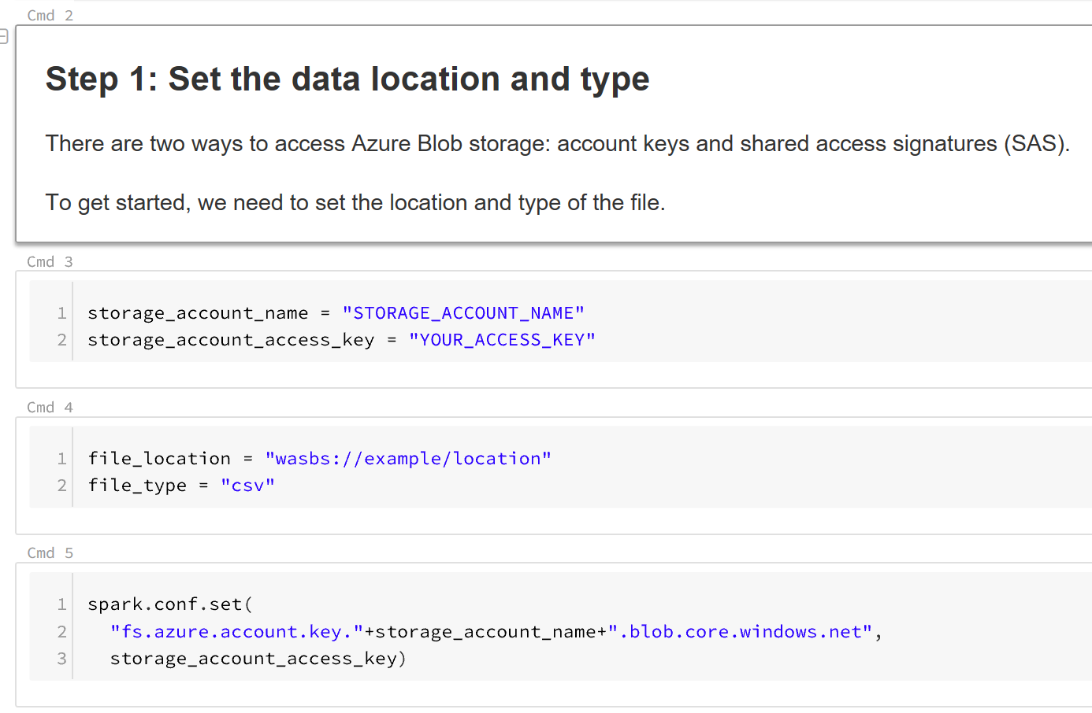
7. Navigate to your storage account where the output of the scored flights is saved to get the necessary attributes. (Note: you’ll find this under “Access keys” in the settings of your storage account.)  
   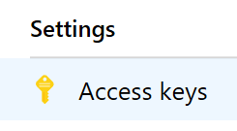
8. For “Cmd 3” replace the values for storage_account_name and storage_account_access_key in the code, and add a value for “storage_container_name” and press “Shift + Enter” The resulting code should look similar to this:  
     
   storage_account_name = "cgm5sparkstorage"  
   storage_account_access_key = "xxx…..xxx=="   
   storage_container_name = "scoredflights"
9. For “Cmd 4” we need to tell databricks the appropriate path to our scored flight data. Replace the contents of the cell with and press “Shift + Enter” :  
     
   file_location = "wasb://"+storage_container_name+"@"+storage_account_name+".blob.core.windows.net/"  
   file_type = "csv"
10. The blob storage connection information is complete. Step 2 in the notebook is made up of a single cell which reads the data. We need to change this step so it reads our header information off the file. To do this replace the contents of “Cmd 7” with and press “Shift + Enter”:  
      
    df = spark.read.format(file_type).options(header="true",inferSchema="true").load(file_location)
11. Databricks now has your data in a “data frame” which we can use to query the data in a variety of ways. In Step 3 of the notebook we begin querying the data. In order to prevent errors when writing sql queries against the table later on, we need to fix some special characters with the headers. To achieve this replace the contents of Cmd 9 with the following and press “Shift + Enter”:  
      
    df = df.withColumnRenamed("Scored Labels", "ScoredLabels")

df = df.withColumnRenamed("Scored Probabilities", "ScoredProbabilities")

display(df.select("OriginAirportCode"))

1. You should be presented a result that shows an abbreviated list of origin airports.  
   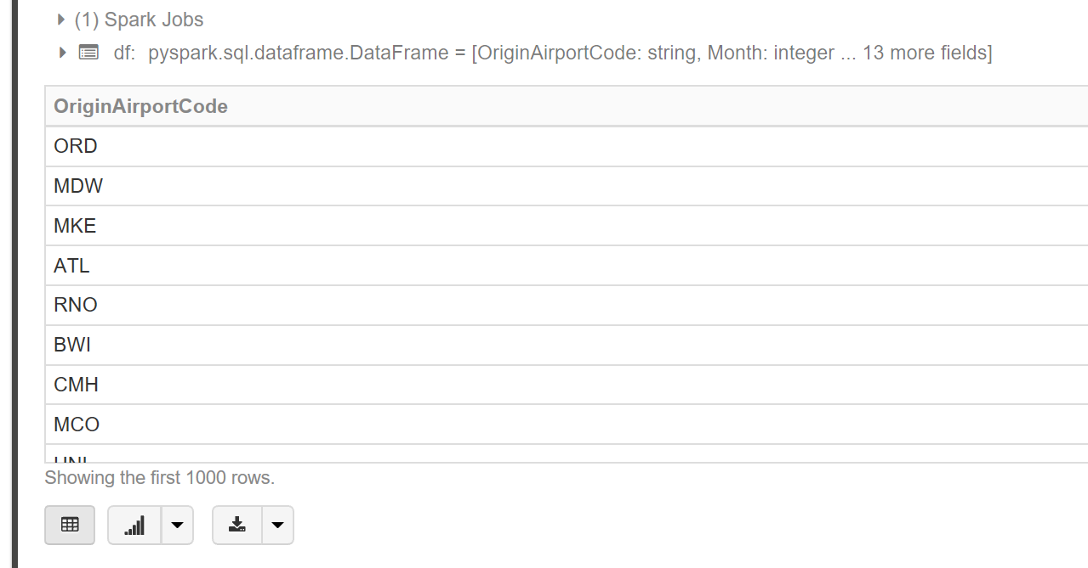
2. Now we have a base structure to query for creating our analytics tables, in Step 4 of the notebook we can register this as a temporary table. Change the contents to the following and hit “Shift + Enter”:  
     
   df.createOrReplaceTempView("TempFlightDelays")
3. To ensure our temp table is working we can query it with normal SQL statements. This is enabled in the notebook by prefixing your cell with “%sql”. Replace the contents of Cmd 13 with the following and press “Shift + Enter”:  
     
   %sql

SELECT OriginAirportCode, AVG(DepDel15) FROM TempFlightDelays GROUP BY OriginAirportCode

1. You should see a result similar to this:  
   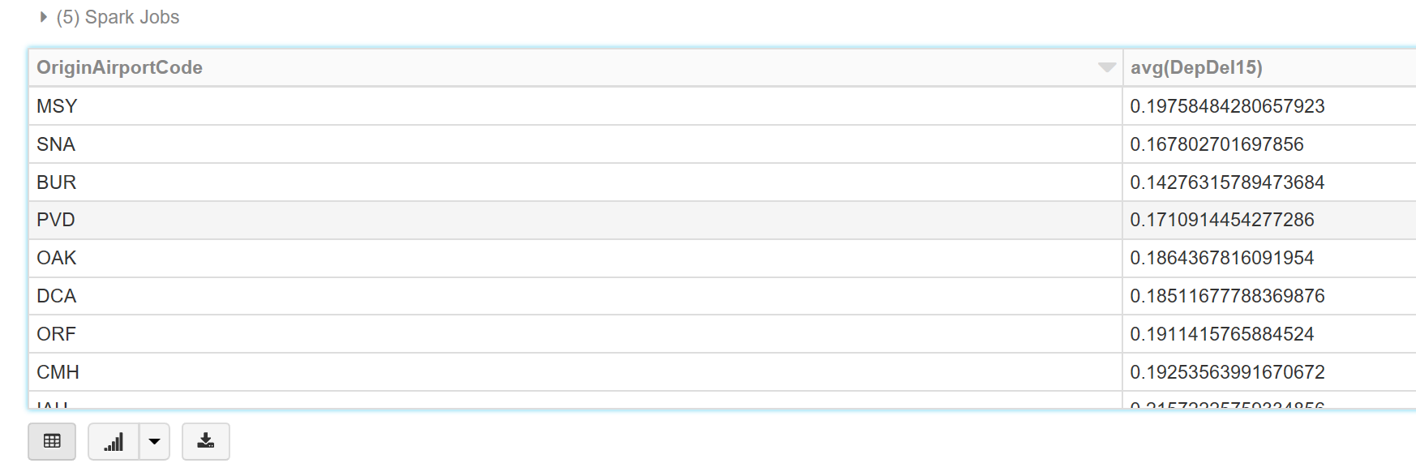
2. Select the **Run cell** button on the toolbar. 
3. Now that we’ve validated our temp table is ready for querying we need to create two tables to support our analyses. First we’ll create a table with all flight delay data. To do this replace Cmd 15 with the following code and press “Shift + Enter”:  
     
   %sql

CREATE TABLE FlightDelays AS

SELECT OriginAirportCode,

DestAirportCode,

concat(LATITUDE, ',', LONGITUDE) AS OriginLatLong,

Month,

DayOfMonth AS Day,

CRSDepHour AS Hour,

Carrier,

ScoredLabels AS DelayPredicted,

ScoredProbabilities AS DelayProbability

FROM TempFlightDelays

1. Now we’ve reached the end of the precreated cells in the notebook template. Add a new cell to the notebook by hovering over the bottom of the cell and clicking the “+” that appears:  
   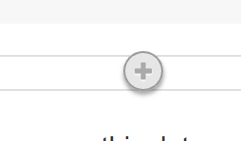
2. In this new cell, we need to add one final SQL command that will create a delay summary table from the FlightDelays table we just created. Enter the following code and press “Shift + Enter”:  
     
   %sql

CREATE TABLE FlightDelaysSummary AS

SELECT OriginAirportCode,

OriginLatLong,

Month,

Day,

Hour,

Sum(DelayPredicted) NumDelays,

Avg(DelayProbability) AvgDelayProbability

FROM FlightDelays

GROUP BY OriginAirportCode, OriginLatLong, Month, Day, Hour

Having Sum(DelayPredicted) > 1

## Exercise 6: Visualizing in Power BI Desktop

#### Task 1: Connect to the Lab VM

1. If you are already, connected to your Lab VM, skip to Task 2.
2. From the left side menu in the Azure portal, click on **Resource groups**, then enter your resource group name into the filter box, and select it from the list. 
3. Next, select your lab virtual machine from the list. 
4. On your Lab VM blade, select **Connect** from the top menu. 
5. Download and open the RDP file.
6. Select Connect, and enter the following credentials:
   1. User name: **demouser**
   2. Password: **Password.1!!**

#### Task 2: Connect to Databricks Power BI Desktop

1. On your Lab VM, launch Power BI Desktop by double-clicking on the desktop shortcut you created in the pre-lab setup.
2. When Power BI Desktop opens, you will need to enter your personal information, or Sign in if you already have an account.

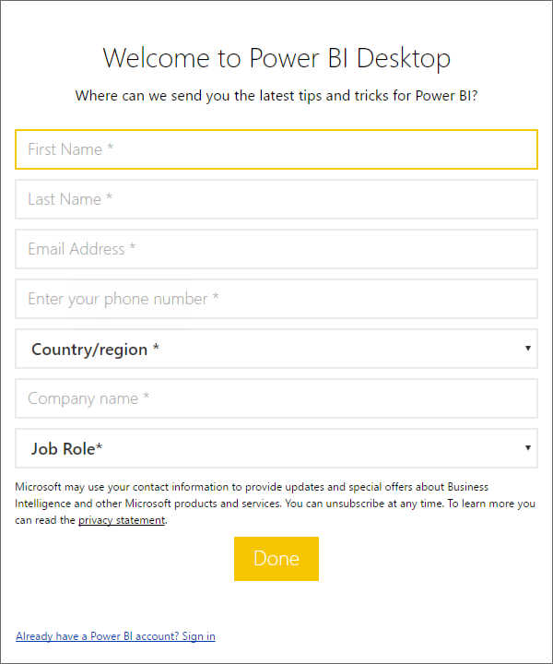

1. Select Get data on the screen that is displayed next. 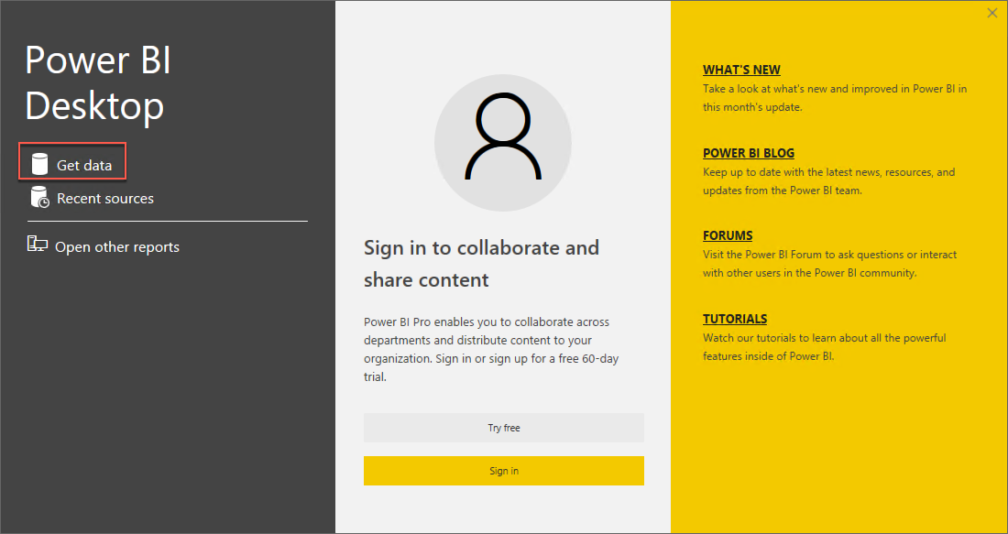
2. Select **Other** from the left, and select **Spark** from the list of available data sources. 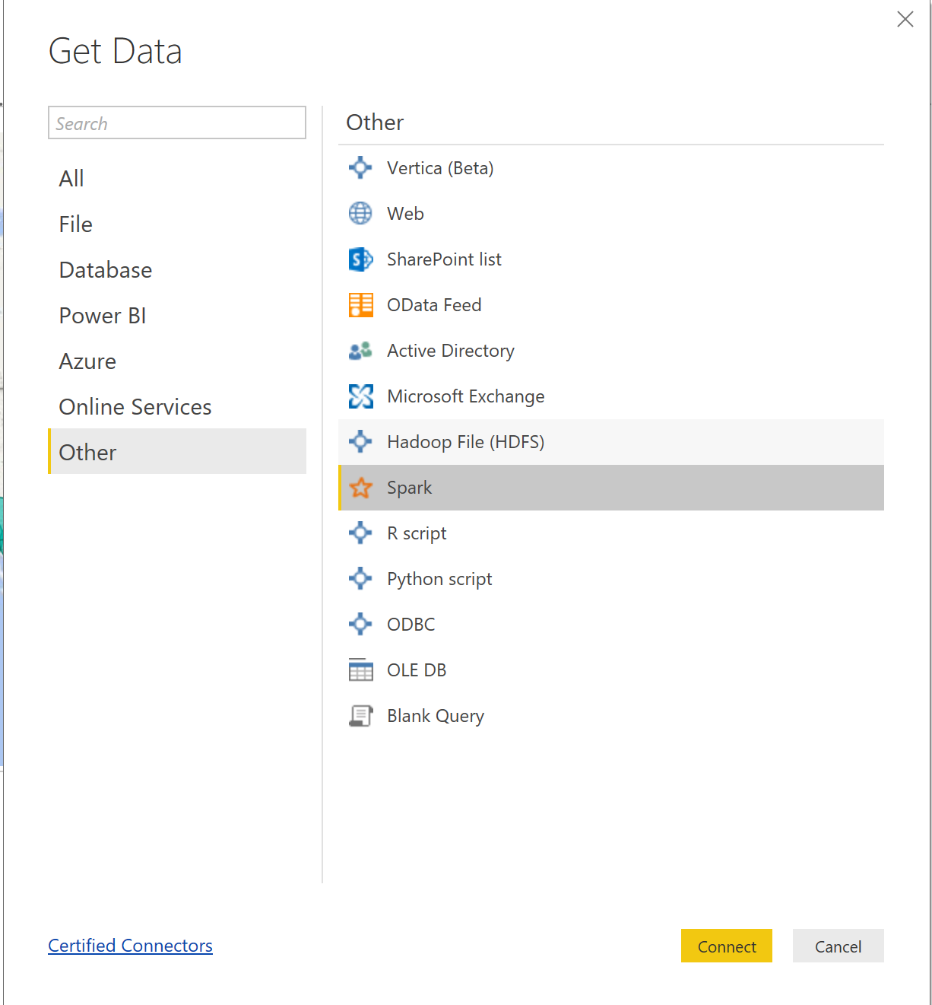
3. Select **Connect**.
4. On the next screen, you will be prompted for your Spark server connection string. 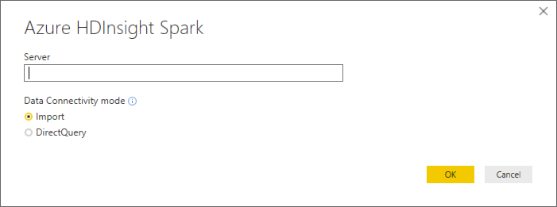
5. To find your Spark cluster connection information, to to the Databricks portal, navigate to clusters, and select the apprpriate server cluster.
6. On the cluster edit page, scroll down and select the **JDBC/ODBC** tab.  
   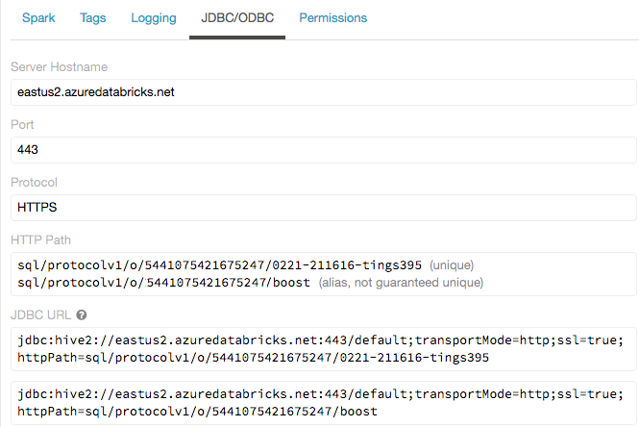
7. On the JDBC/ODBC tab, copy and save the JDBC URL.
8. Construct the JDBC server address that you will use when you set up your Spark cluster connection in Power BI Desktop.

Take the JDBC URL that you copied and saved in step 3 and do the following:

* 1. Replace jdbc:hive2 with https.
  2. Remove everything in the path between the port number and sql, retaining the components indicated by the boxes in the image below.

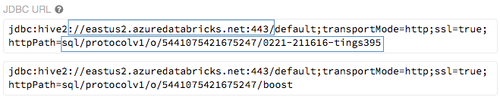  
  
In our example, the server address would be:

https://eastus2.azuredatabricks.net:443/sql/protocolv1/o/5441075421675247/0221-211616-tings395

1. Copy the URL, and paste it into the Server box on the Power BI Spark dialog, select HTTP for the Protocol.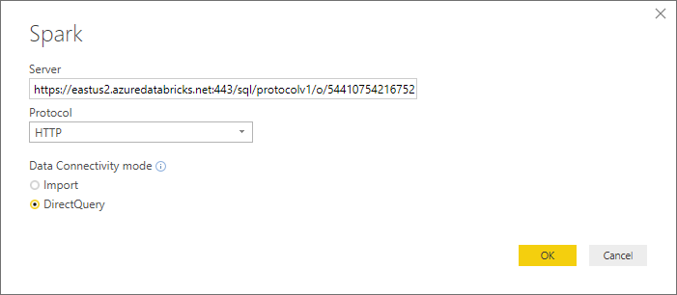
2. Select DirectQuery for the Data Connectivity mode, and select **OK**.
3. On the next screen you’ll need to enter security details to connect to the Databricks cluster. In order to do this we must generate a persaonal access token. In the Databricks cluster click the user icon in the top right.  
   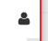
4. Next click on “User Settings”  
   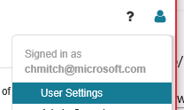
5. In the user settings screen, click **“Generate Token”**.  
   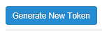
6. Accept the defaults and click **“Generate”.**  
   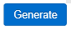
7. Copy the key from the next dialogue box and click **“Done”**.  
     
   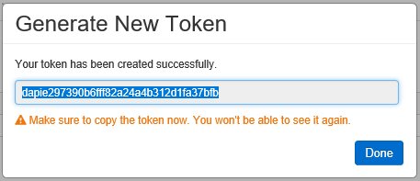
8. Now that you’ve copied this token we can enter the Power BI login credentials as follows:
   1. User name: **token**
   2. Password: **<copied token value>**

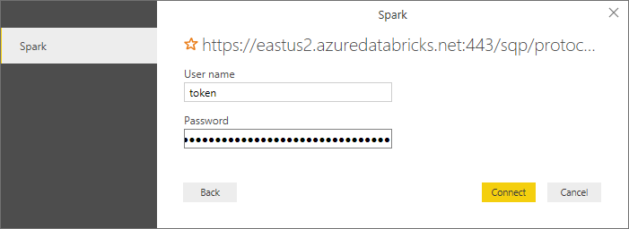

1. Select **Connect**.
2. In the Navigator dialog, check the box next to **flightdelayssummary**, and select **Load**.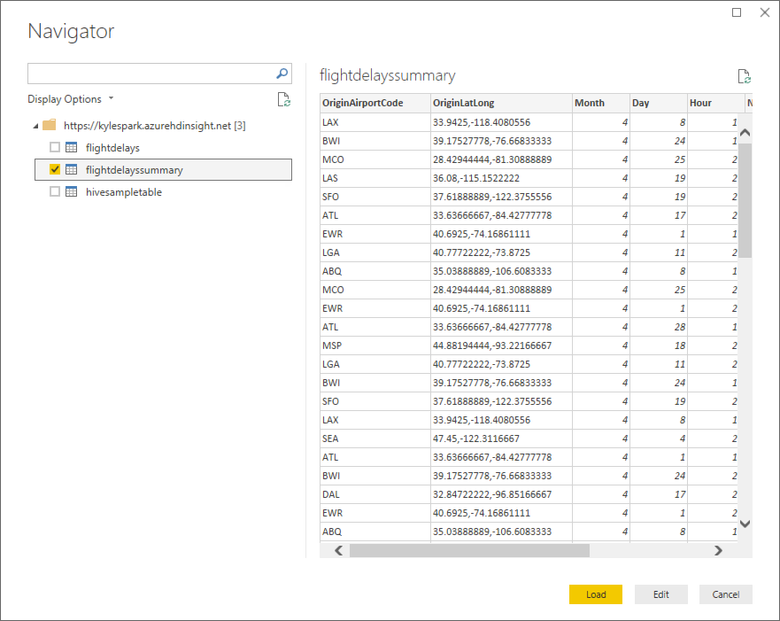

#### Task 3: Create Power BI report

1. Once the data finishes loading, you will see the fields appear on the far right of the Power BI Desktop client window.

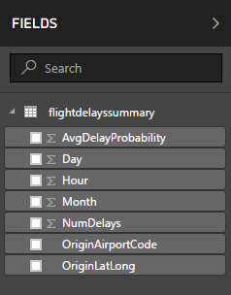

1. From the Visualizations area, next to Fields, select the Globe icon to add a Map visualization to the report design surface.

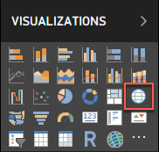

1. With the Map visualization still selected, drag the **OriginLatLong** field to the **Location** field under Visualizations. Then Next, drag the **NumDelays** field to the **Size** field under Visualizations.

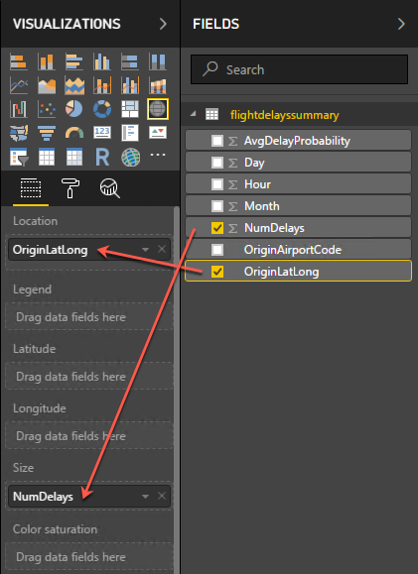

1. You should now see a map that looks similar to the following (resize and zoom on your map if necessary): 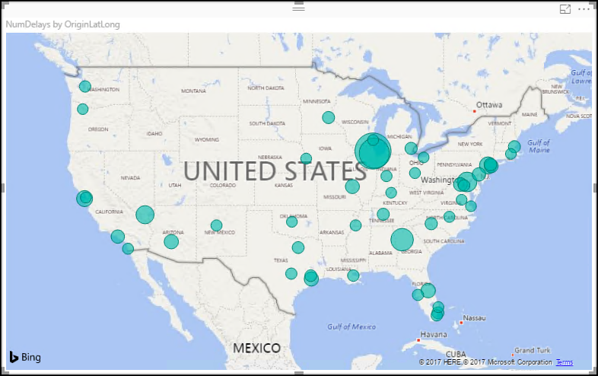
2. Unselect the Map visualization by clicking on the white space next to the map in the report area.
3. From the Visualizations area, select the **Stacked Column Chart** icon to add a bar chart visual to the report’s design surface.

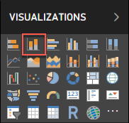

1. With the Stacked Column Chart still selected, drag the **Day** field and drop it into the **Axis** field located under Visualizations.
2. Next, drag the **AvgDelayProbability** field over, and drop it into the **Value** field. 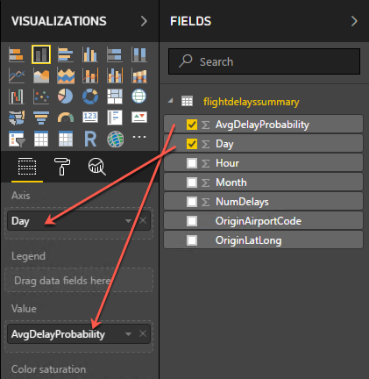
3. Grab the corner of the new Stacked Column Chart visual on the report design surface, and drag it out to make it as wide as the bottom of your report design surface. It should look something like the following. 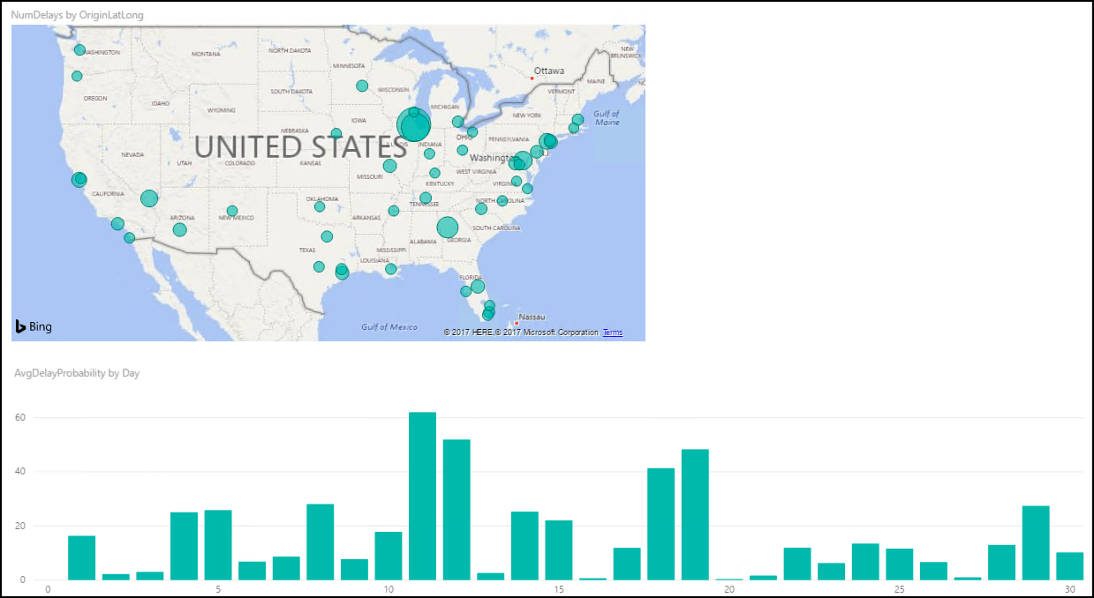
4. Unselect the Stacked Column Chart visual by clicking on the white space next to the map on the design surface.
5. From the Visualizations area, select the Treemap icon to add this visualization to the report. 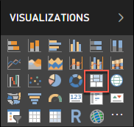
6. With the Treemap visualization selected, drag the **OriginAirportCode** field into the **Group** field under Visualizations.
7. Next, drag the **NumDelays** field over, and drop it into the **Values** field. 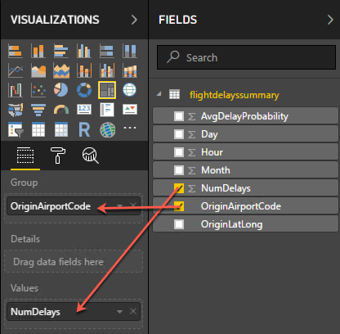
8. Grab the corner of the Treemap visual on the report design surface, and expand it to fill the area between the map and the right edge of the design surface. The report should now look similar to the following. 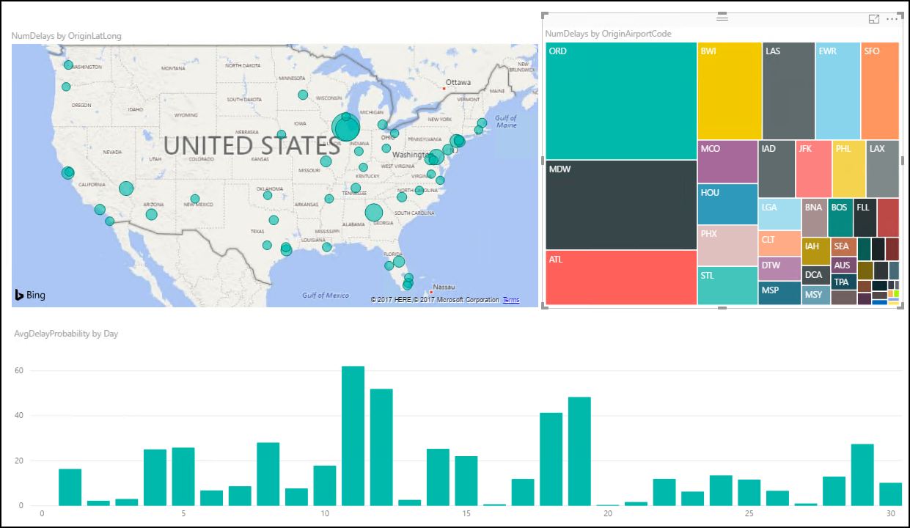
9. You can cross filter any of the visualizations on the report by clicking on one of the other visuals within the report, as shown below. (This may take a few seconds to change, as the data is loaded.) 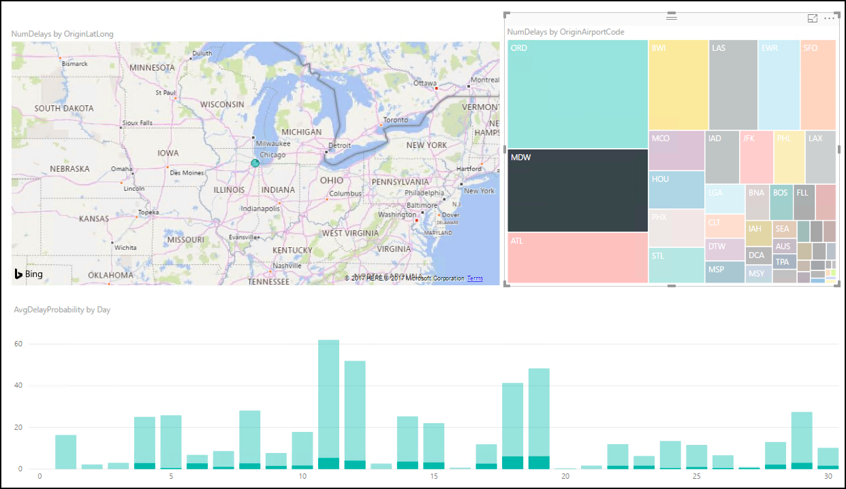
10. You can save the report, by clicking Save from the File menu, and entering a name and location for the file. 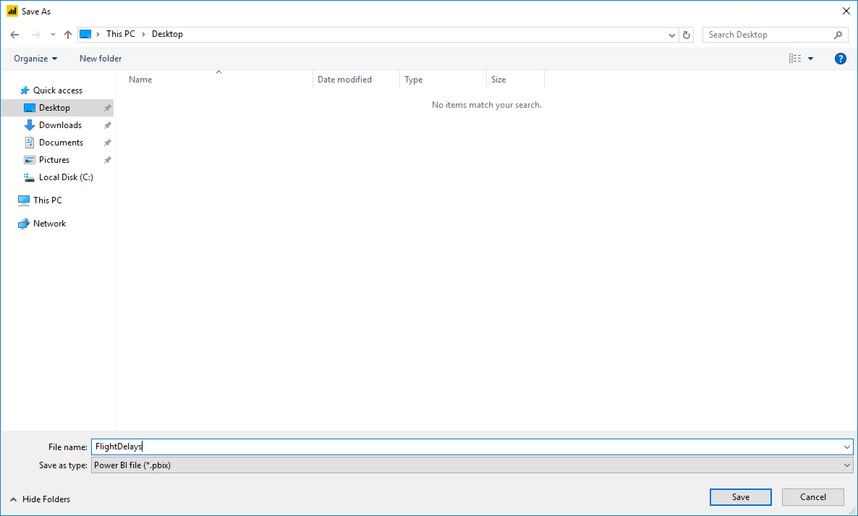

## After the hands-on lab

Duration: 10 minutes

In this exercise, attendees will deprovision any Azure resources that were created in support of the lab.

#### Task 1: Delete resource group

1. Using the Azure portal, navigate to the Resource group you used throughout this hands-on lab by selecting **Resource groups** in the left menu.
2. Search for the name of your research group and select it from the list.
3. Select **Delete** in the command bar and confirm the deletion by re-typing the Resource group name and selecting **Delete**.

You should follow all steps provided *after* attending the Hands-on lab.

## Appendix A: Alternative to Azure ML Exercise

Duration: 20 mins

Synopsis: The purpose of this exercise is the same as Exercise 1 above. However, it is included as an alternative in the case attendees fall behind or are otherwise unable to complete the exercise. The attendee will import a complete predictive experiment into a workspace that he or she already created. This exercise assumes the attendee has already completed the first task of Exercise 1.

#### Task 1: Import the Completed Predictive Experiment Into Your Workspace

1. Go to <https://aka.ms/flightdelaymodel>. This will open a completed version of the ML predictive experiment in the Azure AI Gallery.
2. Click the **Open in Studio** button on the right side of the screen.

[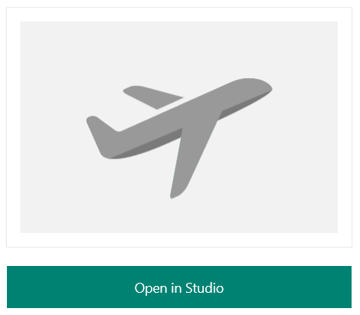](https://github.com/toddkitta/CortanaIntelligenceSuiteWorkshopManual/blob/master/images/import_the_completed_predictive_experiment_into_your_workspace_0.png)

1. When prompted on the next screen, select the **South Central US** region and your workspace.

[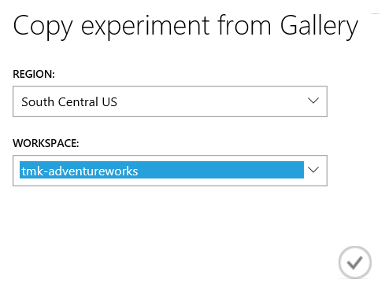](https://github.com/toddkitta/CortanaIntelligenceSuiteWorkshopManual/blob/master/images/import_the_completed_predictive_experiment_into_your_workspace_1.png)

1. After the copy operation finishes, the completed ML experiment will appear in your workspace.

[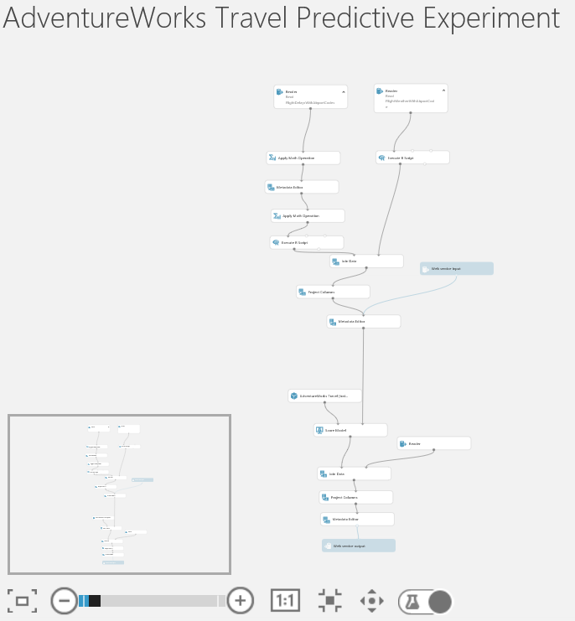](https://github.com/toddkitta/CortanaIntelligenceSuiteWorkshopManual/blob/master/images/import_the_completed_predictive_experiment_into_your_workspace_2.png)

1. Run the experiment. This will take 5-7 minutes.
2. At this point, you are now ready to return to and complete Exercise 1. The only task remaining is Task 9.

## Appendix B: Alternative to Azure Data Factory Exercise

Duration: 10 mins

Synopsis: The purpose of this exercise is to provide a "get out of jail free" card for the Azure Data Factory exercises. If you recall, the architecture of this workshop uses Azure Data Factory to score each row of a file that has flight and weather data in it. Therefore, this exercise will simply have you upload a file that has already been scored so you can continue with the remaining exercises. The file that is being uploaded is the same as the file that would result from completing Exercise 4 (Operationalize ML Scoring with Azure ML and Data Factory).

#### Task 1: Download the Pre-Scored File

1. Go to [Scored Flight Data](https://github.com/chmitch/ocp-big-data-and-visualization/blob/master/Data/ScoredFlights.csv) and download the file (NOTE: to download from Github in the browser, right click on the Download button, then select **Save Link as…**) and save it to **C:\Data** as **ScoredFlights.csv**
2. Once the file is downloaded, go to the [Azure Portal](http://portal.azure.com/) and find the storage account that is the underlying storage for the Spark cluster; it will be called **XXXsparkstorage** (where **XXX** is the App Name you provided when you deployed the workshop prerequisites). An easy way to find your storage account is to navigate to the resource group you created during the workshop setup using the Resource Group item on the leftmost navigation area in the portal. Once you select your resource group you will see all of the resources that were created for the workshop (including the storage account).
3. Once here, select **Blobs** from the storage account blade (while making sure **Overview** is selected in the storage account navigation area).

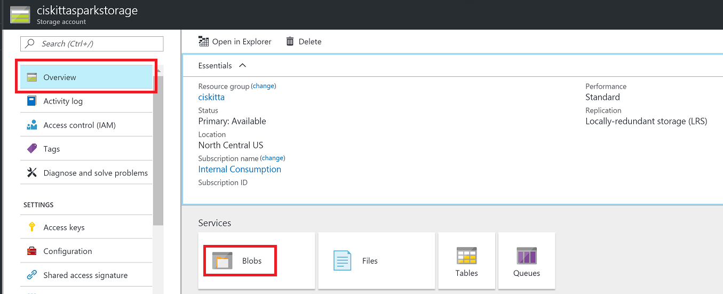

1. Next, select the sparkstorage storage account that is prefixed with the App name you provided in the pre-lab setup.



1. Select **Blobs** in the Services section (or



1. Create a new container, by selecting the **“+ Container”** option



1. Enter the name “scoredflights” and select “Private” for the public access level, then select “**OK**”



1. Next, you will upload the data files from step 3 to “scoredflights”. Select the “scoredflights” container.
2. Select the **Upload** option. This will bring up the “Upload blob” blade.
3. Select the file upload button, then browse to **C:\Data\** and select the **ScoredFlights.csv** file. Select the **Upload** button that should be enabled once you’ve selected the file.

